CHAPTER ONE

INTRODUCTION

1.1 BACKGROUND OF THE STUDY
Chronic Kidney Disease (CKD) is among the most pressing non-communicable health challenges of the present era. The most recent Global Burden of Disease analysis estimates that 788 million adults worldwide were living with CKD in 2023, more than double the figure recorded in 1990, corresponding to an age-standardised prevalence of approximately 14.2 per cent (GBD Chronic Kidney Disease Collaborators, 2025). For advocacy and communication, the global nephrology societies place the wider burden of all kidney disease at more than 850 million people (Jager et al., 2019). The condition is defined by the presence of kidney damage or a glomerular filtration rate (GFR) below 60 mL/min/1.73 m² persisting for three months or longer, irrespective of cause (Levey et al., 2005; Stevens et al., 2024), and it is fundamentally progressive in nature. Its principal drivers, diabetes mellitus and hypertension, are themselves widespread, so that the population at risk continues to expand as the global population ages (GBD Chronic Kidney Disease Collaborators, 2025).
A defining and dangerous characteristic of CKD is that most patients remain asymptomatic during its early stages, precisely the window in which clinical intervention is most effective; many are unaware they have the condition at all (Chen, Knicely and Grams, 2019; Hannan et al., 2024). Because the symptoms are subtle or entirely absent until the disease is advanced, a large proportion of patients are identified only when they have reached end-stage renal disease (ESRD). At that point the available treatments, principally long-term dialysis and kidney transplantation, are costly, invasive, and life-altering, and they impose an enormous financial strain on public health systems. Early detection therefore represents the single most effective lever for slowing disease progression, preserving quality of life, and containing cost (Stevens et al., 2024).
Electronic Health Records (EHRs) offer a promising foundation for earlier detection. An EHR captures a comprehensive digital footprint of a patient over time, including laboratory results, medication histories, recorded comorbidities, and demographic information (Jawad, Verma and Amsaad, 2024). When this longitudinal record is analysed with machine learning (ML), it becomes possible to identify the complex, non-linear patterns that precede a clinical diagnosis and that conventional risk scores tend to overlook (Gogoi and Arul Valan, 2024). Ensemble learning methods in particular, such as Random Forest and Extreme Gradient Boosting (XGBoost), have demonstrated strong predictive performance on the structured, tabular data typical of clinical records, with several studies reporting high accuracy in classifying CKD risk from such features (Ghosh and Khandoker, 2024; Jawad, Verma and Amsaad, 2024).
Despite this promise, two obstacles continue to prevent predictive models from being deployed in routine clinical practice. The first is data privacy. Clinical data is fragmented across many institutions, and stringent regulations, including the Health Insurance Portability and Accountability Act (HIPAA) and the General Data Protection Regulation (GDPR), restrict the centralisation of patient records for the purpose of model training (Rauniyar et al., 2024). The second is interpretability. The highest-performing models tend to behave as opaque “black boxes,” offering little insight into why a particular patient has been flagged as high risk, which undermines the trust clinicians must place in a system before they will act on its output (Ribeiro, Singh and Guestrin, 2016).
Two technological developments speak directly to these obstacles. Federated Learning (FL) enables a shared model to be trained collaboratively across multiple institutions without any raw patient data ever leaving its hospital of origin; only model updates are exchanged (McMahan et al., 2017; Ridwan, 2024). Explainable Artificial Intelligence (XAI), through model-agnostic techniques such as SHapley Additive exPlanations (SHAP) and Local Interpretable Model-agnostic Explanations (LIME), renders a model’s reasoning transparent and auditable against established medical knowledge (Ribeiro, Singh and Guestrin, 2016; Lundberg and Lee, 2017). This study is positioned at the intersection of these two developments, proposing a framework that combines federated learning and explainable AI to deliver a privacy-preserving and clinically trustworthy system for the early detection of CKD (Jahin, Maliha and Hassan, 2024).

1.2 PROBLEM STATEMENT
The central problem addressed by this study is the difficulty of developing and deploying CKD detection models that are simultaneously high-performing, interpretable, and compliant with privacy regulation within a multi-institutional setting. This overarching problem can be decomposed into three specific and interlocking issues.
First is the problem of data silos and statistical heterogeneity. Robust models require large and demographically diverse datasets in order to generalise across patient populations, yet clinical data is typically locked within the isolated databases of individual hospitals. These silos deny researchers access to the scale of data that accurate models demand. Compounding this, different institutions serve different populations and follow different clinical and record-keeping practices, producing data that is not independently and identically distributed (non-IID); such heterogeneity is known to degrade the performance of naively trained models if it is not explicitly addressed (Gogoi and Arul Valan, 2024; Rauniyar et al., 2024). There is therefore a need for an architecture that can learn across institutions while remaining robust to heterogeneous, non-IID data.
Second is the absence of privacy-preserving training mechanisms for collaborative research. Conventional machine learning requires data to be pooled in a central repository, a practice that carries significant security risk and routinely conflicts with patient confidentiality agreements and data protection law. The threat of data breaches, together with the administrative burden of data-sharing agreements, frequently stalls collaborative healthcare AI projects before they begin, leaving many institutions unable to benefit from advanced predictive analytics (Rauniyar et al., 2024). There is therefore a need for a training mechanism that allows institutions to collaborate without exposing raw patient data, reinforced by formal privacy guarantees.
Third is the interpretability crisis that blocks clinical adoption. Although models such as XGBoost and deep neural networks can achieve high predictive accuracy, they offer little explanation for their outputs (Ribeiro, Singh and Guestrin, 2016). In the specific context of CKD, a clinician needs to understand why a patient has been classified as high risk, whether the driver is a rising serum creatinine level, a falling haemoglobin level, or a combination of advancing age and pre-existing hypertension. Without this contextual reasoning, a model is perceived as an untrustworthy black box and its predictions are unlikely to be acted upon at the point of care (Nguycharoen, 2024). There is therefore a need for a system that couples high diagnostic performance with transparent, clinically meaningful explanations.

1.3 AIM OF THE STUDY
The aim of this research is to develop, implement, and evaluate a decentralised, privacy-preserving, and interpretable machine learning framework for the early detection of Chronic Kidney Disease using multi-institutional Electronic Health Records.

1.4 RESEARCH OBJECTIVES
To achieve this aim, the study pursues the following specific objectives:
1. To design a Federated Learning architecture, establishing a secure and scalable server–client structure that supports the decentralised training of CKD prediction models across multiple simulated hospital nodes.
2. To develop high-performance predictive models, implementing and optimising ensemble machine learning algorithms, specifically Random Forest and XGBoost, to classify CKD risk from structured EHR data.
3. To integrate Explainable AI frameworks, applying the post-hoc interpretability methods SHAP and LIME to provide both global and local transparency for the federated models.
4. To evaluate system performance and trustworthiness, measuring the framework using standard predictive metrics (accuracy, AUC-ROC, F1-score) alongside XAI-specific metrics (fidelity, stability, and interpretability).
5. To analyse privacy–utility trade-offs, investigating the impact of privacy-enhancing technologies, namely Homomorphic Encryption and Differential Privacy, on the predictive accuracy and interpretability of the federated CKD model.

1.5 SIGNIFICANCE OF THE STUDY
The significance of this study lies in its potential to narrow the gap between the capabilities of modern artificial intelligence and the practical, regulatory, and ethical requirements of clinical practice. Its contribution can be understood along four strands.
Enhanced clinical trust and adoption. By delivering interpretable outputs through XAI, the proposed system converts opaque predictions into actionable clinical insight. Clinicians are able to see which biomarkers drive a given patient’s risk profile, such as serum creatinine or albumin levels, and the inclusion of both global and local explanations allows the model’s reasoning to be audited and validated against medical standards, fostering the trust on which adoption depends.
Scalable privacy-preserving collaboration. The use of federated learning allows institutions to train high-performance models collaboratively without ever sharing sensitive patient data. This lowers the legal and ethical barriers to multi-institutional research and supports compliance with global data protection regulation, while permitting the framework to scale across many hospitals and thereby produce more robust, less site-specific models.
Improved patient outcomes and economic efficiency. Because early detection is the most effective means of slowing CKD progression and preventing end-stage renal disease, a reliable early-screening tool can enable earlier intervention, better disease management, and improved quality of life. In reducing the number of patients who progress to dialysis or transplantation, the approach also has the potential to relieve a substantial financial burden on health systems.
Theoretical and technical contribution. The study contributes to the emerging field of interpretable and privacy-preserving artificial intelligence by providing empirical evidence on the integration of federated learning and explainable AI in a medical context, and by offering a methodology for balancing the often-competing demands of predictive power, data privacy, and model transparency.

1.6 SCOPE AND LIMITATIONS
This section delineates the boundaries of the study in order to set clear expectations and to disclose, at the outset, the constraints under which the work is conducted.
Scope. The study is concerned with the early detection of CKD from structured, tabular clinical data. The experimental work is built upon the publicly available UCI Machine Learning Repository CKD dataset, supplemented by data structures representative of larger EHR systems. A multi-institutional environment is created by partitioning this public data into separate client nodes that simulate distinct hospitals, including under non-IID conditions. The predictive component is restricted to ensemble methods, principally XGBoost and Random Forest; interpretability is provided through SHAP and LIME; and the privacy analysis examines Differential Privacy and Homomorphic Encryption within a federated averaging scheme.
It must be stated plainly that the hospital nodes in this study are simulated partitions of public data rather than live feeds from real clinical institutions. This choice is deliberate and necessary, since access to genuine multi-hospital EHR data is itself constrained by the very privacy barriers the study seeks to address; it is nonetheless a limitation that bears on how the results should be interpreted.
Limitations. Three limitations in particular should be acknowledged from the outset and are revisited in the discussion of results. First, the primary UCI dataset is small, comprising four hundred cases, which constrains the strength of any claims about generalisation and invites caution regarding very high reported accuracies. Second, simulated partitions, however carefully constructed, cannot fully reproduce the statistical heterogeneity of genuinely independent hospital populations, so the non-IID conditions modelled here are an approximation of real-world conditions. Third, Homomorphic Encryption introduces a meaningful computational overhead, and this cost shapes which model families it can practically be applied to within a federated setting.
Out of scope. The study does not extend to live deployment within a hospital’s information systems, to real-time inference at the point of care, to the analysis of medical imaging or unstructured clinical text, or to a prospective clinical trial. These lie beyond the present work and are identified among the directions for future research.

1.7 DEFINITION OF TERMS
The following terms recur throughout the thesis and are defined here for the benefit of readers who may not specialise in machine learning.
Chronic Kidney Disease (CKD): A progressive loss of kidney function, defined by kidney damage or a reduced glomerular filtration rate persisting for three months or more.
Electronic Health Record (EHR): A digital record of a patient’s medical history, including laboratory results, medications, comorbidities, and demographics.
Federated Learning (FL): A decentralised training paradigm in which a shared model is trained across multiple data holders without raw data leaving any local site; only model updates are exchanged.
Federated Averaging (FedAvg): The standard aggregation algorithm of federated learning, by which a central server combines locally trained model updates into a single global model.
Non-IID data: Data that is not independently and identically distributed; in this context, the differing patient populations and recording practices across institutions.
Explainable Artificial Intelligence (XAI): A set of techniques that make the predictions of a machine learning model transparent and interpretable to human users.
SHAP (SHapley Additive exPlanations): A game-theoretic method that attributes a model’s prediction to its input features, providing globally consistent feature-importance explanations.
LIME (Local Interpretable Model-agnostic Explanations): A method that explains an individual prediction by fitting a simple, interpretable surrogate model in the local neighbourhood of that case.
Differential Privacy (DP): A formal privacy guarantee achieved by adding calibrated noise to data or model updates so that individuals cannot be re-identified from released outputs.
Homomorphic Encryption (HE): An encryption scheme permitting computation to be performed directly on encrypted data, so that a server may aggregate model updates without observing their plaintext values.
eGFR (estimated Glomerular Filtration Rate): An estimate of kidney filtering capacity derived from blood test results; a central indicator in the staging of CKD.

1.8 ORGANISATION OF THE PROJECT
The remainder of this project is organised into four chapters.
Chapter Two reviews the relevant literature across four strands, machine learning for CKD prediction, federated learning in healthcare, explainable AI in clinical settings, and privacy-enhancing technologies, and identifies the specific research gap the study addresses.
Chapter Three sets out the methodology and implementation, formalising the federated learning design, the predictive models, the explainability and privacy mechanisms, and the experimental configuration.
Chapter Four presents and discusses the results, structured around the five research objectives, reporting predictive performance, the privacy–utility trade-off, the explainability outputs, and the limitations of the findings.
Chapter Five concludes the thesis, restating its contributions against the stated objectives and outlining recommendations and directions for future work.

CHAPTER TWO

LITERATURE REVIEW

2.0 INTRODUCTION
This chapter reviews the concepts, technologies, and prior studies that underpin the present research. It begins by establishing the clinical background of Chronic Kidney Disease (CKD), including the structure and function of the kidney, the definition and staging of the disease, its symptoms, diagnosis, and management. It then introduces machine learning and its principal categories, together with its applications and limitations in the healthcare sector, with particular attention to the data-privacy challenges that motivate this work. The two enabling technologies at the centre of the study, Federated Learning and Explainable Artificial Intelligence, are then examined in turn. Finally, the chapter surveys related works on CKD prediction, examining what was done, the techniques and datasets used, the tools employed, and the results obtained, before drawing these together into a summary of the research gap that the present study addresses.

2.1 CHRONIC KIDNEY DISEASE
Chronic Kidney Disease is among the most significant non-communicable diseases of the modern era, and its global burden continues to grow. The most recent Global Burden of Disease analysis estimates that 788 million adults were living with CKD in 2023, more than double the number recorded in 1990, corresponding to an age-standardised prevalence of approximately 14.2 per cent of the adult population (GBD Chronic Kidney Disease Collaborators, 2025). For purposes of advocacy and communication, the international nephrology societies place the combined burden of all forms of kidney disease at more than 850 million people worldwide (Jager et al., 2019). CKD was the ninth leading cause of death globally in 2023, accounting for almost 1.5 million deaths, and its prevalence is rising steadily as populations age and as its principal drivers, diabetes mellitus and hypertension, become more widespread (GBD Chronic Kidney Disease Collaborators, 2025).
To appreciate the nature of the disease, it is helpful first to consider the organ it affects. The kidneys are a pair of bean-shaped organs situated towards the back of the abdomen, beneath the ribs, and they perform several functions essential to health. Their primary role is to filter the blood, removing metabolic waste products and excess fluid, which are excreted as urine; in addition, they regulate the balance of water and electrolytes such as sodium and potassium, help control blood pressure, maintain acid-base balance, and produce hormones involved in the formation of red blood cells and the activation of vitamin D (Cleveland Clinic, 2025).
The functional unit of the kidney is the nephron, of which each kidney contains roughly one million. Filtration takes place in three broad stages. Blood first passes through the glomerulus, a dense network of small blood vessels, where water and small solutes are forced out of the bloodstream in a process called glomerular filtration, while larger molecules such as proteins are retained. The resulting filtrate then flows through the renal tubules, where most of the water, nutrients, and useful solutes are reabsorbed into the blood, and additional wastes are secreted into the tubule. What remains is concentrated into urine, which is carried away through the collecting ducts and ureters (LibreTexts, 2024). Because this filtering capacity is central to the kidney's role, the rate at which the glomeruli filter blood, expressed as the glomerular filtration rate (GFR), is regarded as the best overall measure of kidney function and is used clinically to determine the degree of impairment and to track the progression of disease (Levey et al., 2005).
Chronic Kidney Disease arises when this filtering capacity is progressively and irreversibly lost. According to the Kidney Disease: Improving Global Outcomes (KDIGO) guidelines, CKD is defined as the presence of kidney damage or a reduced glomerular filtration rate below 60 mL/min/1.73 m² persisting for three months or longer, irrespective of the underlying cause (Levey et al., 2005; KDIGO, 2024). The requirement that the abnormality persist for at least three months is what distinguishes the chronic condition from acute kidney injury, in which kidney function may decline suddenly but recover. CKD is characterised by the gradual loss of nephron function, most commonly as a consequence of diabetes and hypertension, and it tends to progress over time towards kidney failure if not detected and managed early (Chen, Knicely and Grams, 2019).
A defining and clinically dangerous feature of CKD is that it is usually asymptomatic in its early stages, precisely the period during which treatment is most able to slow or halt its progression. Because the early signs are subtle or absent, many patients are unaware of their condition, and a substantial proportion are diagnosed only once the disease has advanced to end-stage renal disease (ESRD), at which point survival depends on costly and life-altering renal replacement therapy in the form of dialysis or kidney transplantation (Chen, Knicely and Grams, 2019; GBD Chronic Kidney Disease Collaborators, 2025). This silent progression, combined with the scale and cost of advanced disease, is what makes early detection so important and motivates the development of predictive tools capable of identifying at-risk patients before irreversible damage has occurred.

2.2 STAGES OF CHRONIC KIDNEY DISEASE
Chronic Kidney Disease is not a single uniform condition but a spectrum of severity, and the international standard for describing that severity is the classification published by Kidney Disease: Improving Global Outcomes (KDIGO). Under this system, CKD is classified along three dimensions, abbreviated as CGA: the underlying Cause, the Glomerular filtration rate (GFR) category, and the Albuminuria category (KDIGO, 2024). The GFR categories divide kidney function into five stages, while the albuminuria categories describe the degree of protein leakage into the urine, and the two are used together because risk increases as GFR falls and as albuminuria rises (NCBI StatPearls, 2024).
The five GFR-based stages are defined as follows (KDIGO, 2024; UK Kidney Association, 2024):
- Stage G1 — normal or high kidney function, with an eGFR of 90 mL/min/1.73 m² or above, in the presence of other markers of kidney damage.
- Stage G2 — mildly decreased function, eGFR 60–89 mL/min/1.73 m², again only classified as CKD when accompanied by markers of damage.
- Stage G3 — moderately decreased function, subdivided into G3a (eGFR 45–59) and G3b (eGFR 30–44).
- Stage G4 — severely decreased function, eGFR 15–29 mL/min/1.73 m², representing significant impairment.
- Stage G5 — kidney failure, eGFR below 15 mL/min/1.73 m² or the need for dialysis, often referred to as end-stage renal disease.
Albuminuria is graded in three categories, A1 (normal to mildly increased, urine albumin-to-creatinine ratio below 30 mg/g), A2 (moderately increased, 30–300 mg/g), and A3 (severely increased, above 300 mg/g) (KDIGO, 2024). An important nuance, often overlooked, is that a person with an eGFR above 60 mL/min/1.73 m² is not considered to have CKD unless other markers of kidney damage such as albuminuria are also present (UK Kidney Association, 2024). This staging system is significant for the present study because it defines the clinical target a predictive model is ultimately attempting to anticipate: the early identification of patients at risk of progressing through these stages towards kidney failure.

2.2.1 SYMPTOMS OF CHRONIC KIDNEY DISEASE
As noted earlier, a central clinical challenge of CKD is that it is largely asymptomatic in its early stages, and symptoms tend to appear only as the disease becomes advanced (NCBI StatPearls, 2024). When symptoms do emerge, they are frequently non-specific, which can delay diagnosis because they are easily attributed to other causes. Common manifestations of progressing CKD include fatigue and weakness, swelling of the legs, ankles, or feet (oedema) caused by fluid retention, shortness of breath, nausea, loss of appetite, difficulty sleeping, and changes in the frequency or appearance of urination. Because these symptoms overlap with many other conditions and seldom occur until substantial kidney function has already been lost, they are an unreliable basis for early detection. This reinforces the clinical value of biomarker-based screening and of predictive models capable of flagging risk before symptoms appear.

2.2.2 DIAGNOSIS OF CHRONIC KIDNEY DISEASE
Because CKD cannot be reliably detected from symptoms alone, diagnosis depends on laboratory testing of kidney function, and the same measurements form the features on which machine-learning prediction models are trained. The two principal tests are an estimate of the glomerular filtration rate and a measure of albumin in the urine (National Kidney Foundation, 2025).
The estimated glomerular filtration rate (eGFR) is calculated from a patient's serum creatinine level together with age and sex, most commonly using the CKD-EPI equation; creatinine is a waste product of muscle metabolism that healthy kidneys clear from the blood, so a raised serum creatinine level signals reduced filtering capacity (AFP, 2023; National Kidney Foundation, 2025). The urine albumin-to-creatinine ratio (uACR) measures the amount of albumin leaking into the urine; healthy kidneys retain albumin in the blood, so its presence in the urine indicates kidney damage (National Kidney Foundation, 2025). Guidelines recommend screening high-risk groups, including people with diabetes, hypertension, cardiovascular disease, or aged over sixty, using both eGFR and uACR, with abnormal results confirmed by repeat measurement after three months to establish chronicity (NCBI StatPearls, 2024; AFP, 2023). In addition to these core tests, a range of supporting measurements is commonly recorded, including blood urea, haemoglobin and packed cell volume, serum electrolytes such as sodium and potassium, and urine specific gravity. It is precisely this panel of routinely collected clinical variables that provides the structured input features used in machine-learning approaches to CKD prediction.
2.2.3 TREATMENT AND MANAGEMENT OF CHRONIC KIDNEY DISEASE
There is no cure for Chronic Kidney Disease and the damage to the kidneys is generally irreversible; the goal of treatment is therefore to slow the progression of the disease, manage its complications, and preserve kidney function for as long as possible (Cleveland Clinic, 2026). Management begins with control of the underlying causes and risk factors, principally diabetes and hypertension. Blood pressure control is central, and angiotensin-converting enzyme (ACE) inhibitors and angiotensin receptor blockers (ARBs) are widely used because they both lower blood pressure and reduce protein leakage, thereby protecting the kidneys; more recently, sodium-glucose co-transporter-2 (SGLT2) inhibitors have been added for patients with significant albuminuria (AFP, 2023; BC Guidelines, 2024). Additional measures address the complications of declining kidney function, such as phosphate binders, medications to lower cholesterol, erythropoietin to treat anemia, and vitamin D supplementation to protect bone health, alongside dietary changes and lifestyle modification (Cleveland Clinic, 2026).
When the disease reaches end-stage renal failure, these measures are no longer sufficient and survival depends on renal replacement therapy, either dialysis, in which a machine performs the blood-filtering function of the kidneys, or kidney transplantation, which is generally the preferred option for eligible patients because of its survival benefit (NCBI StatPearls, 2024; Cleveland Clinic, 2026). Both options are costly, demanding for the patient, and place a heavy burden on health systems, which is the central reason that early detection, the focus of this study, is so valuable: identifying and treating CKD before it reaches this stage offers the best prospect of avoiding the most severe outcomes.

2.3 MACHINE LEARNING AND ITS TASKS
Machine learning is a branch of artificial intelligence concerned with the design of algorithms that learn patterns from data and improve their performance on a task through experience, rather than being explicitly programmed with fixed rules (IBM, 2023). In the context of disease prediction, this capacity to infer complex relationships directly from data is what allows a model to estimate a patient's risk from their clinical measurements. Machine learning approaches are conventionally grouped into several broad categories according to the nature of the data and the learning signal available.
Supervised learning uses labelled datasets, in which each training example is paired with a known outcome, to learn a mapping from inputs to outputs that can then classify new data or predict outcomes (IBM, 2023). As the model is trained, it adjusts its internal parameters until its predictions fit the labelled examples, a process validated to avoid overfitting or underfitting. Most clinical prediction tasks, including CKD detection, are supervised classification problems, where the input is a set of patient features and the label indicates whether or not the patient has the disease. Common supervised algorithms include logistic regression, k-nearest neighbours, decision trees, support vector machines, naïve Bayes, neural networks, and ensemble methods such as Random Forest and gradient boosting.
Unsupervised learning analyses unlabelled data to discover hidden structure without predefined outcomes, for example by grouping similar records together through clustering or by reducing the number of variables through dimensionality reduction (IBM, 2023). It is well suited to exploratory analysis, pattern discovery, and customer or patient segmentation, with algorithms such as k-means clustering and principal component analysis being typical examples.
Semi-supervised learning occupies a middle ground, using a small quantity of labelled data together with a larger pool of unlabelled data to guide learning, which is valuable when labelled examples are scarce or expensive to obtain (IBM, 2023).
Reinforcement learning, by contrast, trains an agent through trial and error: the agent takes actions within an environment and learns an optimal strategy by receiving rewards or penalties based on the outcomes of those actions.
Because the prediction of CKD from structured Electronic Health Record data involves known input variables and a known target label, the present study adopts the supervised learning approach, and specifically its classification branch, to meet its objectives.

2.3.1 ENSEMBLE LEARNING AND TREE-BASED METHODS
Within supervised learning, a particularly important family of techniques for the present study is ensemble learning. A single model, such as one decision tree, has characteristic weaknesses: it is easy to interpret but tends to overfit the training data and generalise poorly (DataCamp, 2026). Ensemble methods address this by combining the predictions of many individual models so that their separate errors tend to cancel out, producing a result that is usually more accurate and more reliable than any single model alone (Towards Data Science, 2025). Two ensemble strategies dominate practical use, and the two algorithms central to this study are leading representatives of each.
Random Forest is based on a strategy called bagging, or bootstrap aggregating. It constructs many decision trees in parallel, each trained on a random sample of the data drawn with replacement and using a random subset of features, and then combines them by majority vote for classification (Breiman, 2001). This randomness produces a collection of uncorrelated trees, which greatly reduces the risk of overfitting and yields a model that is robust to outliers and does not require the input features to be scaled (Towards Data Science, 2025).
XGBoost (Extreme Gradient Boosting) is based instead on boosting, in which decision trees are built sequentially, each new tree attempting to correct the errors of those before it, so that the model improves incrementally at each step (Chen and Guestrin, 2016). XGBoost has become widely regarded as the leading algorithm for structured, tabular data, valued for its speed, scalability, and predictive performance (DataCamp, 2026).
The choice of these methods for the present study is well founded in the literature. Tree-based ensemble models are interpretable relative to other high-performing approaches, robust against overfitting and outliers, able to handle mixed data types, and do not require feature scaling (Wang et al., 2023). Critically, a growing body of evidence indicates that on tabular data of the kind found in Electronic Health Records, ensemble methods such as Random Forest and gradient boosting can match or outperform far more complex deep-learning models, which typically require much larger datasets to converge and greater computational resources (Khan et al., 2025). This combination of strong performance on tabular clinical data, resilience, and relative efficiency is what makes XGBoost and Random Forest especially appropriate for CKD prediction in the resource-constrained, privacy-sensitive environment that this study addresses.

2.4 APPLICATIONS OF MACHINE LEARNING IN HEALTHCARE
The healthcare sector has emerged as one of the most active and promising domains for the application of machine learning. The continual growth of digital health data, combined with advances in learning algorithms, has enabled systems that support clinicians in tasks ranging from diagnosis to treatment planning, and a substantial body of work now reports diagnostic accuracies competitive with, and in some narrow tasks exceeding, those of human experts (Khan et al., 2025). Some of the principal areas in which machine learning has been applied in healthcare are outlined below.
The most prominent application is in diagnosis and disease identification, where models trained on clinical, laboratory, or imaging data assist in detecting conditions that are difficult to identify in their early stages, including various cancers, diabetes, liver and kidney disease, and cardiovascular conditions (Khan et al., 2025). Closely related is medical imaging analysis, in which computer-vision techniques interpret radiological images such as mammograms, CT scans, and dermatological photographs to flag abnormalities for clinical review. Machine learning also supports drug discovery, accelerating the identification of candidate compounds and personalised drug combinations; personalised treatment, in which a patient's history is analysed to recommend tailored therapy; and health-records management, where techniques such as optical character recognition and natural-language processing help structure and organise the large volumes of unstructured clinical text held in Electronic Health Records (Sermo, 2026). Beyond the clinic, machine learning increasingly underpins remote monitoring through wearable devices and the Internet of Medical Things, enabling continuous, real-time assessment of patients outside hospital settings (NCBI, 2025).
2.4.1 Historical Overview of Machine Learning in Medical Diagnosis
The application of computing to medical diagnosis is not new. The first commercially produced computers came into use in the early 1950s and were quickly adopted by the medical industry as a means of analysing large quantities of medical information efficiently. As the digital storage and dissemination of medical data expanded, it became feasible to develop algorithms that could model and analyse these growing datasets, laying the groundwork for machine-assisted diagnosis.
Among the earliest applications were expert systems developed in the early 1970s. Internist-1, an expert consultant program for diagnosis in general internal medicine, employed a probabilistic approach that contributed to the later development of Bayesian networks and approximate inference. Around the same time, MYCIN (so named after the '-mycin' suffix common to antibiotics) was developed at Stanford University to diagnose blood-borne infections and recommend treatments. Although these early systems produced promising diagnostic results, they were never deployed in routine clinical practice, owing to a combination of practical limitations and ethical concerns. Over the following decades, as algorithms became more capable and reliable and as computing power and data availability grew, machine learning evolved from these rule-based expert systems into the data-driven statistical learning methods that dominate medical prediction today.

2.4.2 PROBLEMS FACED IN USING MACHINE LEARNING FOR MEDICAL DIAGNOSIS
Despite its evident promise, the practical deployment of machine learning in medical diagnosis is constrained by a set of persistent and interrelated challenges. These difficulties are directly relevant to the present study, because the framework it proposes is designed specifically to address several of them.
The foremost challenge is data privacy and governance. Medical data is among the most sensitive categories of personal information, and its use is tightly governed by regulations such as the Health Insurance Portability and Accountability Act (HIPAA) in the United States and the General Data Protection Regulation (GDPR) in Europe (AIS Technolabs, 2026). Because of these protections, the large-scale, real-world clinical datasets needed for robust research are frequently unavailable for unrestricted use, and privacy must be considered at every stage of the machine-learning pipeline, from training through to inference (Guerra-Manzanares et al., 2023).
A second, closely related challenge is the existence of data silos and fragmentation. As medical care has become more specialised, a patient's records are distributed across many different facilities and computer systems, a phenomenon often described as fragmentation in medicine (Hu et al., 2019). Integrating this dispersed information into a single dataset is obstructed by privacy and security concerns, the absence of standardised data formats, the use of proprietary technologies by different vendors, and costly data-access arrangements (Hu et al., 2019). The comprehensive datasets that would best support research, often containing more than one hundred thousand subjects, are typically proprietary and require approval from advisory committees together with access charges.
A third challenge concerns data quality and model generalisation. Clinical data is frequently noisy or incomplete, with missing values that demand considerable preprocessing before a model can be trained (Junaid et al., 2023). Moreover, data drawn from a single source can be significantly biased by the equipment, demographics, and acquisition protocols of that institution, so that models trained at one site often fail to generalise to broader or different patient populations (Bhatt et al., 2022). Overcoming this requires exposure to large and diverse datasets, which returns once again to the privacy and fragmentation barriers described above.
Taken together, these challenges define the central tension that motivates this study: the most accurate models require large, diverse, multi-institutional datasets, yet the privacy, governance, and fragmentation of medical data make the centralisation of such datasets difficult or impossible. It is precisely this tension that Federated Learning is designed to resolve, and it is to this technology that the review now turns.

2.5 FEDERATED LEARNING
Federated Learning (FL) is a decentralised machine-learning paradigm that directly addresses the tension identified in the previous section: it enables a shared model to be trained collaboratively across data held at many different locations without that data ever being centralised (McMahan et al., 2017). Originally proposed by McMahan and colleagues at Google for training predictive models across large numbers of mobile devices, the approach has since been widely adopted in the medical sector precisely because of its privacy-enhancing properties and its compatibility with the regulatory restrictions that govern the sharing of health data (Rauniyar et al., 2024). The defining principle of FL is that the model travels to the data rather than the data travelling to the model: each participating institution trains on its own local records, and only model parameters, never raw patient data, are ever shared.
In the standard formulation, a federated learning system comprises three components: a number of participating clients, each representing an institution or data holder such as a hospital; a central aggregation server that coordinates the process; and the communication protocols through which model parameters are securely exchanged (Wang et al., 2026). The collective of clients together with the server is referred to as the federation. This architecture allows institutions to collaborate on building a model while retaining full sovereignty over their own data and remaining compliant with privacy regulation.
The training process proceeds iteratively over a series of communication rounds. In each round, the server first distributes the current global model to the participating clients; each client then trains this model on its own local dataset for a number of iterations; the clients send their updated model parameters back to the server; and the server aggregates these updates into an improved global model, which is redistributed at the start of the next round (Kaur et al., 2025). This cycle repeats until the model converges. Because only model updates cross the network, the raw clinical data never leaves the institution in which it was collected, which is the source of the paradigm's privacy guarantee.

2.5.1 FEDERATED AVERAGING (FEDAVG)
The foundational and most widely used aggregation algorithm in federated learning is Federated Averaging (FedAvg), introduced in the original work of McMahan et al. (2017). In FedAvg, each client trains the global model on its local data for several epochs using stochastic gradient descent, and then transmits the resulting parameters to the central server. The server combines these contributions by computing a weighted average, where each client's contribution is weighted in proportion to the size of its local dataset, to produce the updated global model (Wang et al., 2026). Formally, the global model parameters at round t + 1 are obtained as:
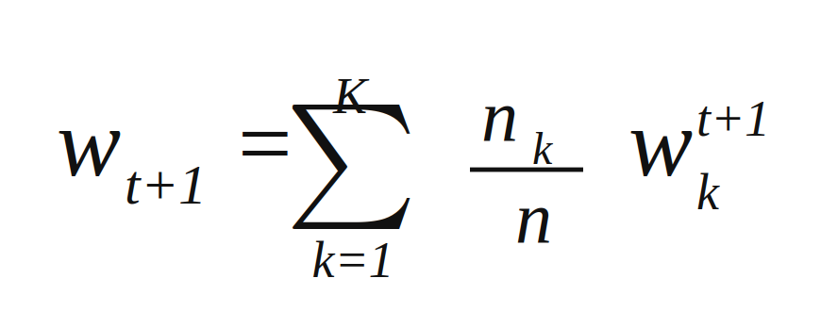
where w<sub>k</sub><sup>t+1</sup> denotes the parameters from client k after local training, n<sub>k</sub> is the number of samples held by client k, and n is the total number of samples across all K clients. FedAvg is valued for its simplicity and its communication efficiency, since it requires relatively few exchanges between server and clients to reach a useful model (Rauniyar et al., 2024). For these reasons it is adopted as the aggregation algorithm in the present study.

2.5.2 FEDERATED LEARNING IN HEALTHCARE AND THE CHALLENGE OF NON-IID DATA
The privacy-preserving character of federated learning has made it especially attractive in healthcare, where it has been applied to tasks such as mortality prediction, length-of-stay estimation, disease diagnosis, and the analysis of distributed Electronic Health Records (Antunes et al., 2022). For tabular clinical datasets of the kind used in this study, multilayer perceptrons and tree-based models are common choices of learner, while convolutional networks dominate medical-imaging applications (Nguyen et al., 2021). By allowing models to be trained across several hospitals, federated learning can in principle produce more robust and generalisable models than any single institution could build alone, while respecting the data-sovereignty constraints described earlier.
This benefit is tempered, however, by a central technical challenge: the problem of non-IID data. The FedAvg algorithm implicitly assumes that the data held by different clients is independently and identically distributed, that is, drawn from a similar underlying distribution (Wang et al., 2026). In real healthcare settings this assumption rarely holds. Different hospitals serve different patient demographics and follow different clinical and data-recording practices, so that each client's data follows a distinct distribution (Antunes et al., 2022). This statistical heterogeneity can slow convergence and degrade the performance of the global model if it is not explicitly accounted for, and addressing it is an active area of research and a recognised limitation that any federated healthcare study must confront. The present study therefore examines model behaviour under both homogeneous and heterogeneous (non-IID) partitions of the data, in order to assess the robustness of the federated approach under realistic conditions.
A further consideration is that, although federated learning prevents the direct sharing of raw data, the model updates that are exchanged can themselves leak information about the underlying data under certain attacks. For this reason, federated learning is frequently combined with additional privacy-enhancing technologies, such as differential privacy and homomorphic encryption, a subject examined later in this chapter.

2.6 EXPLAINABLE ARTIFICIAL INTELLIGENCE
The machine-learning models that achieve the highest predictive accuracy, including the ensemble methods central to this study and deep neural networks, are commonly described as "black boxes": they produce predictions without revealing the reasoning behind them (Razzak et al., 2025). This characteristic reflects a long-recognised tension in machine learning between accuracy and interpretability. Simple models such as linear or logistic regression are easy to interpret but often lack predictive power, whereas the complex models that perform best tend to be opaque (Bücker et al., 2023). In most domains this opacity is merely inconvenient, but in high-stakes settings such as medicine it is a serious obstacle to adoption, because a clinician cannot safely act on a prediction whose basis they cannot examine, and accountability for a decision cannot rest on an unexplained output.
Explainable Artificial Intelligence (XAI) is the field that addresses this problem, providing techniques that allow human users to understand and trust the predictions of machine-learning models (Mishra et al., 2025). A useful distinction within XAI is between methods that explain a single prediction, known as local explanations, and methods that describe the behaviour of the model across an entire dataset, known as global explanations (Chen et al., 2022). Equally important for this study is that the two methods adopted are model-agnostic and post-hoc: they can be applied to any trained classifier, regardless of its internal structure, and are used after training to interpret a model that has already been built (Bücker et al., 2023). The two most widely adopted XAI techniques, and the two employed in this research, are SHAP and LIME.

2.6.1 SHAPLEY ADDITIVE EXPLANATIONS (SHAP)
SHAP, introduced by Lundberg and Lee (2017), is grounded in cooperative game theory. It treats each input feature as a "player" in a game whose payoff is the model's prediction, and uses the concept of the Shapley value to distribute the credit for that prediction fairly among the features (Lundberg and Lee, 2017). For a given prediction, each feature is assigned a SHAP value representing the magnitude and direction of its contribution: a positive value pushes the prediction towards the positive class, a negative value away from it. A particular strength of SHAP is that the same framework provides both local and global explanations: the SHAP values for an individual patient explain that specific prediction, while aggregating SHAP values across all patients yields a consistent, global picture of which features matter most to the model overall (Bhattacharya et al., 2023). This consistency, derived from the mathematical properties of the Shapley value, is the main reason SHAP is regarded as a reliable measure of feature importance. Its principal drawback is computational cost, since the exact calculation of Shapley values is expensive; in practice, optimised estimators such as KernelSHAP and TreeSHAP are used, the latter being particularly efficient for the tree-based models employed in this study (Hassan et al., 2023).

2.6.2 LOCAL INTERPRETABLE MODEL-AGNOSTIC EXPLANATIONS (LIME)
LIME, proposed by Ribeiro, Singh and Guestrin (2016), takes a different and more localised approach. To explain an individual prediction, LIME generates a set of perturbed versions of the input by making small random changes to its feature values, observes how the black-box model's predictions change in response, and then fits a simple, interpretable model, such as a sparse linear model, to this local neighbourhood (Ribeiro, Singh and Guestrin, 2016). The resulting surrogate approximates the behaviour of the complex model in the vicinity of the instance being explained, indicating which features drove that particular prediction and in which direction. LIME's strength is its intuitive, case-by-case interpretability, which makes it well suited to producing patient-specific explanations that a clinician can review (Chen et al., 2022). Its principal limitation, widely noted in the literature, is instability: because the explanations depend on random perturbations, repeated applications to the same instance can yield somewhat different results, which has prompted the development of more deterministic variants (Hassan et al., 2023). In this study, SHAP and LIME are used in a complementary fashion, SHAP providing globally consistent feature-importance analysis across the whole patient population and LIME providing local, individual explanations for specific cases.

2.6.3 EXPLAINABLE AI IN CKD PREDICTION
The application of XAI to Chronic Kidney Disease prediction has grown rapidly, and SHAP and LIME have become the dominant tools in this work. A consistent and clinically encouraging finding across these studies is that the features the models rely upon align closely with established medical knowledge. SHAP analyses of CKD models have repeatedly identified haemoglobin, albumin, serum creatinine, and the estimated glomerular filtration rate among the most influential predictors, which are precisely the biomarkers clinicians use to assess kidney function (Ahmed et al., 2024). Studies combining XGBoost or Random Forest with SHAP and LIME report that the addition of these explanation methods improves the interpretability of otherwise opaque models and helps physicians understand the reasoning behind each prediction, thereby supporting trust and clinical uptake (Ahmed et al., 2024; Ghosh and Khandoker, 2024). This body of work establishes that interpretable, accurate CKD prediction is achievable on centralised data. What remains comparatively unexplored, and what this study addresses, is the integration of these explanation methods into a federated setting, so that the transparency they provide can be obtained without compromising the privacy of the underlying patient data.

2.7 PRIVACY-ENHANCING TECHNOLOGIES IN FEDERATED LEARNING
Although federated learning keeps raw data local, the model updates it exchanges can, under certain attacks, leak information about the data on which they were trained, for example through gradient-reconstruction attacks that attempt to recover training examples from shared parameters (Wei et al., 2023). To close this residual gap, federated learning is commonly reinforced with privacy-enhancing technologies. The two most prominent, and the two examined in this study, are Differential Privacy and Homomorphic Encryption. They protect privacy in fundamentally different ways, and the trade-offs between them form the basis of Objective 5 of this research.
Differential Privacy (DP) is a formal, mathematical definition of privacy that protects individual records by ensuring that the output of a computation is essentially insensitive to whether any single individual's data was included (Zhang et al., 2023). In practice this is achieved by adding carefully calibrated random noise, typically drawn from a Gaussian or Laplace distribution, to the model updates before they are shared. The strength of the guarantee is controlled by a privacy budget, denoted ε (epsilon): a smaller ε means more noise and stronger privacy, but also greater distortion of the model and therefore lower accuracy (Liu et al., 2022). Differential privacy is computationally cheap, but it protects privacy at a direct cost to utility, and this tension between privacy budget and predictive performance is precisely the kind of trade-off this study sets out to quantify.
Homomorphic Encryption (HE) takes a cryptographic rather than a statistical approach. It is a form of encryption that allows computations to be performed directly on encrypted data, such that the decrypted result is identical to the result that would have been obtained on the original, unencrypted values (Yi et al., 2024). Applied to federated learning, this allows each client to encrypt its model updates before transmission, and allows the server to aggregate those updates while they remain encrypted, so that the server never sees any individual client's parameters in plaintext. Two schemes are especially relevant. The Paillier cryptosystem is an additive scheme, well suited to the summation involved in federated averaging but limited to linear operations (Paillier, 1999). The CKKS scheme supports approximate arithmetic on real numbers and is widely regarded as the most efficient option for the kind of computation found in machine learning, though it remains more demanding (Cheon et al., 2017). The principal advantage of homomorphic encryption is that, unlike differential privacy, it preserves model accuracy, since no noise is introduced; its principal disadvantage is a substantial computational and communication overhead, which can be orders of magnitude greater than computation on unencrypted data (Jin et al., 2023). In this study, homomorphic encryption is implemented using the TenSEAL library.
The contrast between these two technologies, differential privacy trading accuracy for low cost, and homomorphic encryption preserving accuracy at high computational cost, defines the privacy–utility–efficiency trade-off that this research investigates empirically.

2.8 RELATED WORKS
A considerable body of research has addressed the prediction of Chronic Kidney Disease using machine learning, and the studies surveyed here are grouped into four broad categories: conventional machine-learning approaches, explainable-AI approaches, federated-learning approaches, and approaches that combine privacy preservation with interpretability. For each study, the technique used, the dataset, the implementation, and the reported results are considered, in order to establish what has been achieved and where the limitations lie.

Conventional Machine-Learning Approaches
Khalid et al. (2023) in "Machine Learning Hybrid Model for the Prediction of Chronic Kidney Disease," published in Computational Intelligence and Neuroscience, proposed a hybrid ensemble model for CKD prediction using the UCI Chronic Kidney Disease dataset of 400 instances. Pearson correlation was used for feature selection, and Gaussian Naïve Bayes, gradient boosting, and a decision tree were combined as base classifiers with a random forest acting as the meta-classifier. Implemented in Python, the individual models achieved high accuracies — gradient boosting around 99 per cent, random forest 98 per cent, and the decision tree 96 per cent — while the proposed hybrid model reportedly reached 100 per cent accuracy on the same dataset. The near-perfect accuracy, however, raises concerns about overfitting on this small and relatively clean dataset.
Poonia et al. (2022) in their article "Intelligent Diagnostic Prediction and Classification Models for Detection of Kidney Disease," published in Healthcare, applied K-nearest neighbours, artificial neural networks, support vector machines, and Naïve Bayes to the UCI dataset of 400 cases and 24 features, using Recursive Feature Elimination and Chi-Square tests for feature selection. A logistic regression model optimised with Chi-Square-selected features achieved the highest accuracy of 98.75 per cent, demonstrating the value of careful feature selection in CKD classification.
Pal (2022) in the article "Chronic Kidney Disease Prediction Using Machine Learning Techniques," published in Biomedical Materials & Devices, developed a CKD prediction model on the same 400-instance UCI dataset, applying logistic regression, decision tree, and support vector machine classifiers and enhancing performance with a bagging ensemble method. The decision tree classifier achieved an accuracy of 95.92 per cent, which improved to 97.23 per cent after the bagging method was applied, illustrating the benefit of ensemble techniques over single classifiers.
Islam et al. (2024) in "ML-CKDP: Machine learning-based chronic kidney disease prediction with smart web application," published in the Journal of Pathology Informatics, built a model with a comprehensive preprocessing pipeline — categorical-to-numerical conversion, imputation of missing values, and Min-Max normalisation — together with multiple feature-selection techniques. Seven classifiers were employed, including Random Forest, AdaBoost, Gradient Boosting, XGBoost, Naïve Bayes, SVM, and Decision Tree, and the work was extended into a web-based application for CKD prediction, achieving accuracies above 98 per cent. This study is notable for moving beyond classification towards a deployable tool.
Emon et al. (2021) in their article "Performance Analysis of Machine Learning Approaches in Automatic Classification of Chronic Kidney Disease," published in the International Journal of Engineering and Advanced Technology, evaluated a range of classifiers on the UCI dataset and reported that the Random Forest model achieved the maximum accuracy, justifying its applicability as an effective tool for the early diagnosis of CKD. The study is representative of the consistent finding across this literature that tree-based ensemble methods perform strongly on structured CKD data.
Saif et al. (2024) in the article "Machine Learning Techniques in Chronic Kidney Diseases: A Comparative Study of Classification Model Performance," published in Cureus, obtained data from the UCI repository and trained Random Forest, SVM, Logistic Regression, XGBoost, and KNN classifiers using an 80:20 train-test split. Evaluated by area under the ROC curve, SVM, Random Forest, Logistic Regression, and XGBoost all showed excellent performance with AUC values close to the maximum, while KNN recorded the lowest AUC at 0.93, confirming the relative weakness of distance-based methods on this task.
Qin et al. (2020) in "A Machine Learning Methodology for Diagnosing Chronic Kidney Disease," published in IEEE Access, addressed the practical problem of missing values in the UCI CKD dataset and proposed an integrated model combining logistic regression and random forest using a perceptron, which achieved an accuracy of 99.83 per cent. The study is frequently cited as a benchmark for CKD prediction and highlights the importance of principled handling of missing clinical data.

Explainable Artificial Intelligence Approaches
Ghosh and Khandoker (2024) in "Investigation on explainable machine learning models to predict chronic kidney diseases," published in Scientific Reports, applied an XAI-based strategy to clinical data from 491 patients (56 with CKD and 435 without), encompassing clinical, laboratory, and demographic variables. Five machine-learning methods were employed: logistic regression, random forest, decision tree, Naïve Bayes, and XGBoost and the optimal model was selected by accuracy and AUC. The XGBoost model achieved the best performance, with an AUC of 0.9689 and an accuracy of 93.29 per cent, and SHAP and LIME were applied to interpret it. Feature-importance analysis identified creatinine, glycosylated haemoglobin (HbA1c), and age as the three most influential predictors, with SHAP force plots illustrating individualised predictions and LIME providing case-level explanations. The study, however, was conducted entirely on centralised data from a single source.
Chouit et al. (2026) in "Interpretable machine learning for chronic kidney disease prediction: Insights from SHAP and LIME analyses," published in PLOS One, developed an interpretable framework using XGBoost with SHAP and LIME, and notably evaluated it on two datasets: the UAE Tawam Hospital data (n = 491) and the UCI CKD data (n = 400). With SMOTE optimisation and deliberate overfitting prevention, the model achieved 88.4 per cent accuracy (AUC = 0.904) on the hospital dataset and 94.6 per cent accuracy (AUC = 0.948) on the UCI dataset. SHAP analysis surfaced clinically relevant predictors, including eGFR, HbA1c, and cholesterol for the hospital cohort and specific gravity, haemoglobin, and serum creatinine for the UCI cohort. Although it used two datasets, each was processed centrally rather than collaboratively, and privacy preservation was not addressed.
Raihan et al. (2023) in "Explainable Chronic Kidney Disease Prediction using Deep Learning and Shapley Additive Explanations (SHAP)," published in the Proceedings of the 7th International Conference on Advances in Artificial Intelligence (ICAAI), first applied two ensemble approaches, XGBoost and AdaBoost, before proposing a deep neural network to extract and represent features for CKD prognosis. The fine-tuned DNN outperformed the ensemble methods, reaching an accuracy of 98.8 per cent, and SHAP was used to investigate which features contributed to the prediction, with the results confirming established medical explanations. The work demonstrates the use of SHAP for clinical validation but relies on a single centralised dataset.
Rezk et al. (2025) in "Explainable AI for Chronic Kidney Disease Prediction in Medical IoT: Integrating GANs and Few-Shot Learning," published in Bioengineering, addressed missing values using a generative adversarial network and applied few-shot learning techniques, including prototypical networks and model-agnostic meta-learning, alongside conventional classifiers for comparison. SHAP and LIME were applied to interpret the models and identify significant diagnostic parameters. Prototypical networks combined with GANs achieved the highest accuracy at 99.99 per cent. While methodologically sophisticated and interpretable, the framework is centralised and its near-perfect accuracy again suggests caution regarding generalisation.
Elshewey et al. (2025) in "Improved CKD classification based on explainable artificial intelligence with extra trees and BBFS," published in Scientific Reports, combined an Extra Trees classifier with a Binary Brownian-motion-based Feature Selection (BBFS) method and integrated XAI to evaluate the explainability of the model's outcomes. Using eight selected features, the study provided insight into the relative importance of each feature in influencing the model's predictions, advancing the feature-selection dimension of interpretable CKD modelling while remaining a centralised approach.
Shivhare et al. (2025) in "Predictive Modeling for Chronic Kidney Disease," published in the International Journal of Education and Management Engineering, compared several classifiers including XGBoost and AdaBoost and identified logistic regression, random forest, and AdaBoost as the most effective for CKD prediction. The study incorporated SHAP to enhance the explainability of a Random Forest model, using summary, waterfall, and force plots to provide insight into the model's decision-making for both CKD and non-CKD cases. As with the others in this group, transparency was achieved on centrally held data only.

Federated Learning Approaches
Salmeron, J.L., Arévalo, I. and Ruiz-Celma, A. (2023) in "Benchmarking federated strategies in peer-to-peer federated learning for biomedical data," published in Heliyon, evaluated peer-to-peer federated learning on several biomedical datasets including the UCI Chronic Kidney Disease dataset (25 features, 400 patients) split across five simulated hospitals under both even and uneven (non-IID) distributions. Comparing multiple aggregation strategies against standard Federated Averaging, the authors found that accuracy-based weighted averaging outperformed classical FedAvg in 15 of 16 cases. The study federates the same structured UCI CKD data used in the present work and examines the effect of data heterogeneity on aggregation, yet it incorporates no explainability layer and, by the authors' own statement, no privacy-preserving mechanism such as differential privacy or homomorphic encryption.
Suje (2024) in "Chronic Kidney Disease Prediction Using Federated Learning," published via the IEEE proceedings, applied the federated paradigm to CKD prediction across distributed clients, training local models on partitioned data and aggregating them into a global model without centralising patient records. The work confirms the feasibility of privacy-preserving CKD prediction, but, in common with much of the federated literature, it focuses on predictive performance and privacy without addressing the transparency of the resulting model.
Hegde et al. (2025) in "A Privacy-Preserving Federated Learning Method with Homomorphic Encryption for Chronic Kidney Disease Stage Prediction," published in Engineering, Technology & Applied Science Research, implemented a baseline FL framework with one central server and four hospital clients using a real-world CKD dataset, and then subjected it to three simulated adversarial attacks — model inversion, membership inference, and gradient leakage. These assessments revealed significant vulnerabilities in the plain federated setup, which the authors then addressed using homomorphic encryption. This study is particularly relevant to the present work because it directly examines the residual privacy risks of plain federated learning and applies homomorphic encryption as a remedy, though it does not integrate explainability.
Yadav et al. (2026) in "Federated learning with IoT-based remote patient monitoring for real-time chronic disease prediction," published in the Journal of King Saud University – Computer and Information Sciences, proposed a federated, IoT-based framework for real-time CKD prediction that preserves privacy by training locally on distributed wearable devices. An Enhanced Nutcracker Optimisation heuristic selected salient features, pre-trained convolutional architectures extracted high-dimensional features, and a multi-head deep neural network performed the final prediction, all trained under federated learning to avoid transferring sensitive data offsite. The framework illustrates the scalability of FL to real-time, device-level deployment but is computationally heavy and offers no interpretability layer.
Almogadwy and Alqarafi (2025) in "Fused federated learning framework for secure and decentralized patient monitoring in healthcare 5.0 using IoMT," published in Scientific Reports, introduced a Fused Federated Learning approach integrating Internet of Medical Things devices, combining a Real-Time Sequential Deep Extreme Learning Machine with federated aggregation for decentralised CKD diagnosis. The proposed approach achieved an accuracy of 98.21 per cent, outperforming existing federated methodologies. While it advances secure decentralised monitoring, the emphasis remains on accuracy and privacy rather than on explaining the model's decisions to clinicians.

Combined Privacy-Preserving and Explainable Approaches
The studies in the preceding groups each address part of the problem this research targets, but a smaller and more recent body of work has begun to combine privacy preservation with interpretability, and these represent the closest prior work to the present study.
Jahin et al. (2024) in "Privacy-Preserving and Explainable Multi-Hospital CKD Prediction via Federated Learning with Blockchain Logging and Differential Privacy" introduced a federated HistGradientBoosting framework enriched with blockchain logging, differential privacy via DP-SGD, and SHAP-based explainability, with the explicit aim of enabling transparent and secure CKD prediction. A multi-hospital benchmark was constructed using real datasets (UCI and Kaggle) together with synthetic data distributed across five hospitals, with deliberate attention to heterogeneity through missing features and non-IID demographics. This study is among the closest in conception to the present work, combining federation, differential privacy, and explainability; it relies, however, on differential privacy rather than homomorphic encryption for update protection, and uses HistGradientBoosting rather than the XGBoost and Random Forest models examined here, leaving the comparative privacy–utility behaviour of encryption-based protection unaddressed.
Shahid et al. (2026), in "Health-FedNet: secure federated learning for chronic disease prediction on MIMIC-III with differential privacy and homomorphic encryption," published in Scientific Reports, presented a federated framework that integrates three privacy elements simultaneously — calibrated differential privacy, Paillier homomorphic encryption, and secure aggregation — together with SHAP-based feature attribution to interpret the global model, and a node-weighting scheme to stabilise convergence under heterogeneous (non-IID) data. This is arguably the most complete combined framework in the literature, and its co-use of differential privacy and homomorphic encryption closely parallels the privacy analysis proposed in this study; it is evaluated, however, on the MIMIC-III critical-care database for chronic disease generally rather than being focused specifically on early CKD detection using the ensemble models and CKD biomarker features central to this research.
Author et al. (2026), in "An explainable federated blockchain framework with privacy-preserving AI optimization for securing healthcare data," published in Scientific Reports, proposed the Privacy-Preserving Federated Blockchain Explainable AI Optimization (PPFBXAIO) framework, which combines blockchain-based traceability, federated learning, explainable AI, and an optimisation method that secures model weight updates using both homomorphic encryption and differential privacy. The framework directly targets the clinical demand for transparent yet private AI; its emphasis, however, is on the general security architecture for healthcare data across nodes rather than on the early detection of a specific condition such as CKD, and the additional blockchain layer introduces overhead beyond the scope of the present study.
Jawad, Verma and Amsaad (2024) in "AI-Driven Predictive Analytics Approach for Early Prognosis of Chronic Kidney Disease Using Ensemble Learning and Explainable AI," published as an arXiv preprint, combined ensemble learning with explainable AI for early CKD prognosis, using SHAP for global feature importance and LIME for case-by-case explanation of individual predictions. The study is closely aligned with the present work in its choice of ensemble models and dual SHAP–LIME explanation strategy, and it represents a strong centralised precedent; it does not, however, operate in a federated or privacy-preserving setting, so the data-centralisation problem remains unresolved.
Haque et al. (2025) in "Improving Chronic Kidney Disease Detection Efficiency: Fine-Tuned CatBoost and Nature-Inspired Algorithms with Explainable AI," published as an arXiv preprint, proposed a machine-learning framework with explainable AI in which a fine-tuned XGBoost model achieved 100 per cent training and 97.5 per cent testing accuracy, with interpretability provided through SHAP and partial-dependence plots that identified specific gravity and haemoglobin as the most important features. The authors themselves note the study's principal limitations as a lack of external validation, computational cost, and potential overfitting, and the framework is centralised, without any privacy-preserving mechanism.

2.9 RESEARCH GAP
The studies reviewed in the preceding section demonstrate the considerable progress made in the prediction of Chronic Kidney Disease, yet they also reveal a clear and consistent pattern when examined together. The conventional machine-learning studies achieve high predictive accuracy but operate as opaque "black boxes" on centrally held data, addressing neither interpretability nor privacy. The explainable-AI studies successfully open the black box using SHAP and LIME, but they do so on centralised datasets and make no provision for privacy-preserving, multi-institutional training. The federated-learning studies, conversely, resolve the privacy and data-centralisation problem but largely neglect interpretability, producing secure models whose reasoning remains hidden from clinicians. Even the most advanced combined frameworks fall short of the specific configuration this research targets: the closest, such as Jahin et al. (2024) and Health-FedNet, rely on differential privacy alone or address chronic disease in general rather than focusing on early CKD detection, while none provides a direct, quantified analysis of the privacy–utility trade-offs of both differential privacy and homomorphic encryption within a federated, interpretable ensemble-based framework for CKD detection.
In summary, no existing study simultaneously brings together all of the following: a federated learning architecture for early CKD detection, interpretable ensemble models (XGBoost and Random Forest), dual explanation through both SHAP and LIME, and an empirical analysis of the privacy–utility trade-offs of both differential privacy and homomorphic encryption within a federated ensemble-based CKD detection framework. It is precisely this intersection that the present study addresses. The principal limitations of the reviewed works are summarised in Table 2.1.
Table 2.1 RESEARCH GAP
S/N | Article Title | Author (Year) | Methodology | Result Obtained | Limitation
1 | Machine Learning Hybrid Model for the Prediction of CKD | Khalid et al. (2023) | Hybrid ensemble (GNB, GB, DT base; RF meta-classifier); Pearson feature selection | Hybrid model 100%; GB ~99%, RF 98% | Centralised; near-perfect accuracy suggests overfitting on small dataset; no XAI or privacy
2 | Intelligent Diagnostic Prediction and Classification Models for Detection of Kidney Disease | Poonia et al. (2022) | KNN, ANN, SVM, NB; RFE + Chi-Square selection | Logistic regression 98.75% | Centralised; single dataset; no interpretability or privacy
3 | Chronic Kidney Disease Prediction Using Machine Learning Techniques | Pal (2022) | LR, DT, SVM with bagging ensemble | DT 95.92%, rising to 97.23% with bagging | Centralised; no XAI; no privacy mechanism
4 | ML-CKDP: Machine Learning-Based CKD Prediction with Smart Web Application | Islam et al. (2024) | RF, AdaBoost, GB, XGBoost, NB, SVM, DT; web app | Accuracy above 98% | Centralised; no interpretability; no privacy
5 | Performance Analysis of ML Approaches in Automatic Classification of CKD | Emon et al. (2021) | Multiple classifiers on UCI data | Random Forest highest accuracy | Centralised; single dataset; black-box; no privacy
6 | Machine Learning Techniques in CKD: A Comparative Study | Saif et al. (2024) | RF, SVM, LR, XGBoost, KNN; 80:20 split | High AUC for SVM/RF/LR/XGBoost; KNN lowest (0.93) | Centralised; comparison only; no XAI or privacy
7 | A Machine Learning Methodology for Diagnosing CKD | Qin et al. (2020) | Integrated LR + RF via perceptron; missing-value handling | Accuracy 99.83% | Centralised; very high accuracy risks overfitting; no XAI or privacy
8 | Investigation on Explainable ML Models to Predict CKD | Ghosh & Khandoker (2024) | LR, RF, DT, NB, XGBoost; SHAP + LIME | XGBoost AUC 0.9689, accuracy 93.29% | Centralised single-source data; no privacy mechanism
9 | Interpretable ML for CKD Prediction: Insights from SHAP and LIME | Chouit et al. (2026) | XGBoost + SMOTE; SHAP + LIME; two datasets | UCI 94.6% (AUC 0.948); hospital 88.4% | Both datasets processed centrally; no privacy/federation
10 | Explainable CKD Prediction using Deep Learning and SHAP | Raihan et al. (2023) | XGBoost, AdaBoost, then DNN; SHAP | DNN accuracy 98.8% | Centralised; single dataset; no privacy
11 | Explainable AI for CKD Prediction in Medical IoT: GANs and Few-Shot Learning | Rezk et al. (2025) | GAN imputation; prototypical networks, MAML; SHAP + LIME | Prototypical+GAN 99.99% | Centralised; near-perfect accuracy questions generalisation; no privacy
12 | Improved CKD Classification based on XAI with Extra Trees and BBFS | Elshewey et al. (2025) | Extra Trees + Binary Brownian feature selection; XAI | High accuracy on 8 selected features | Centralised; no privacy-preserving mechanism
13 | Predictive Modeling for Chronic Kidney Disease | Shivhare et al. (2025) | XGBoost, AdaBoost, LR, RF; SHAP | LR/RF/AdaBoost most effective; SHAP plots | Centralised; interpretability only; no privacy
14 | Benchmarking federated strategies in peer-to-peer federated learning for biomedical data | Salmeron, J.L., Arévalo, I. and Ruiz-Celma, A. (2023) | Peer-to-peer FL; multiple aggregation strategies vs FedAvg; UCI CKD data (400 patients, 25 features), 5 simulated hospitals, IID + non-IID | Accuracy-based weighted averaging beat FedAvg in 15/16 cases | No XAI; no privacy mechanism (DP/HE), by authors' own statement; uses open-source not real hospital data
15 | Chronic Kidney Disease Prediction Using Federated Learning | Suje (2024) | Federated training across distributed clients | Feasible privacy-preserving CKD prediction | No XAI; focus on accuracy/privacy only
16 | A Privacy-Preserving FL Method with Homomorphic Encryption for CKD Stage Prediction | Hegde et al. (2025) | FL (1 server, 4 clients); HE after attack assessment | HE mitigates inversion/MIA/gradient-leakage attacks | No interpretability; HE only, no DP comparison
17 | Federated Learning with IoT-Based Remote Patient Monitoring for Real-Time Chronic Disease Prediction | Yadav et al. (2026) | FL + IoT; ENO feature selection; CNNs + multi-head DNN | Real-time privacy-preserving prediction | No XAI; computationally heavy
18 | Fused Federated Learning Framework for Secure Decentralised Patient Monitoring (Healthcare 5.0, IoMT) | Almogadwy and Alqarafi (2025) | Fused FL + RTS-DELM; IoMT aggregation | Accuracy 98.21% | No interpretability layer; emphasis on privacy/accuracy
19 | Privacy-Preserving and Explainable Multi-Hospital CKD Prediction via FL with Blockchain Logging and DP | Jahin et al. (2024) | Federated HistGradientBoosting; blockchain logging; DP-SGD; SHAP | Transparent, secure CKD prediction across 5 hospitals | Uses DP not HE; HistGB not XGBoost/RF; no DP-vs-HE comparison
20 | Health-FedNet: Secure FL for Chronic Disease Prediction on MIMIC-III with DP and HE | Shahid et al. (2026) | FL + calibrated DP + Paillier HE + secure aggregation; SHAP; node-weighting | Complete combined privacy framework | Evaluated on general chronic disease (MIMIC-III), not CKD-specific; not ensemble/biomarker focused
21 | An Explainable Federated Blockchain Framework with Privacy-Preserving AI Optimization | (author to confirm) (2026) | Blockchain + FL + XAI + HE + DP (PPFBXAIO) | Transparent, private, traceable model training | General healthcare security focus; not CKD-specific; blockchain overhead
22 | AI-Driven Predictive Analytics for Early Prognosis of CKD Using Ensemble Learning and Explainable AI | Jawad, Verma & Amsaad (2024) | Ensemble learning; SHAP (global) + LIME (local) | Strong centralised CKD prognosis | Centralised; no federation or privacy
23 | Improving CKD Detection: Fine-Tuned CatBoost and Nature-Inspired Algorithms with XAI | Haque et al. (2025) | Fine-tuned XGBoost/CatBoost; SHAP + PDP | XGBoost 97.5% test accuracy | Centralised; authors note no external validation, overfitting; no privacy

CHAPTER THREE

METHODOLOGY AND IMPLEMENTATION

3.0 INTRODUCTION
This chapter presents the methodology and implementation of the proposed framework for the early detection of Chronic Kidney Disease. It is organised into two parts. The first establishes the research design: the overall architecture of the system, the dataset and its preparation, the federated learning structure, the predictive models, the explainability module, and the privacy mechanisms, together with the formal basis of each. The second part addresses implementation: the metrics by which the framework is evaluated, the software tools and libraries used, the experimental configuration, and the measures taken to ensure reproducibility. Throughout, the design choices are related back to the five objectives of the study and to the research gap identified in the preceding chapter, so that the methodology can be seen to address each in turn.

3.1 RESEARCH DESIGN AND SYSTEM ARCHITECTURE
The study adopts an experimental, quantitative research design. A predictive system is designed, implemented, and then evaluated empirically against measurable criteria, namely predictive performance, interpretability, and the privacy–utility trade-off. This design is appropriate because the research questions are answered not by observation or survey but by building a working system and measuring its behaviour under controlled conditions, including the deliberate variation of data distribution and privacy settings.
The proposed framework integrates four components into a single pipeline: a federated learning architecture that trains models across multiple simulated hospital nodes without centralising data; an ensemble-based predictive core, using XGBoost and Random Forest, for high-accuracy CKD classification; an explainability module applying SHAP and LIME to render the model's predictions transparent; and a privacy layer comprising Differential Privacy and Homomorphic Encryption. Because homomorphic encryption operates on model parameters expressed as numerical vectors, it is applied to a weight-based learner on a secondary model track, while differential privacy, which is compatible with tree-based learning, protects the ensemble models; this design decision is explained in full in Section 3.7. Together these components are intended to satisfy the study's central aim, namely a decentralised, privacy-preserving, and interpretable system for early CKD detection.
The overall workflow proceeds in five stages, corresponding to the five objectives of the study. First, the data is prepared and partitioned across simulated hospital nodes to emulate a multi-institutional setting, including both homogeneous (IID) and heterogeneous (non-IID) distributions. Second, predictive models are trained locally at each node and aggregated into a global model through the Federated Averaging algorithm. Third, the explainability module is applied to the converged global model to produce both global and local explanations. Fourth, the system is evaluated using predictive, interpretability, and privacy metrics. Fifth, the privacy mechanisms are introduced and their effect on accuracy and computational cost is measured, yielding the privacy–utility analysis. The architecture of the complete framework is shown in Figure 3.1.
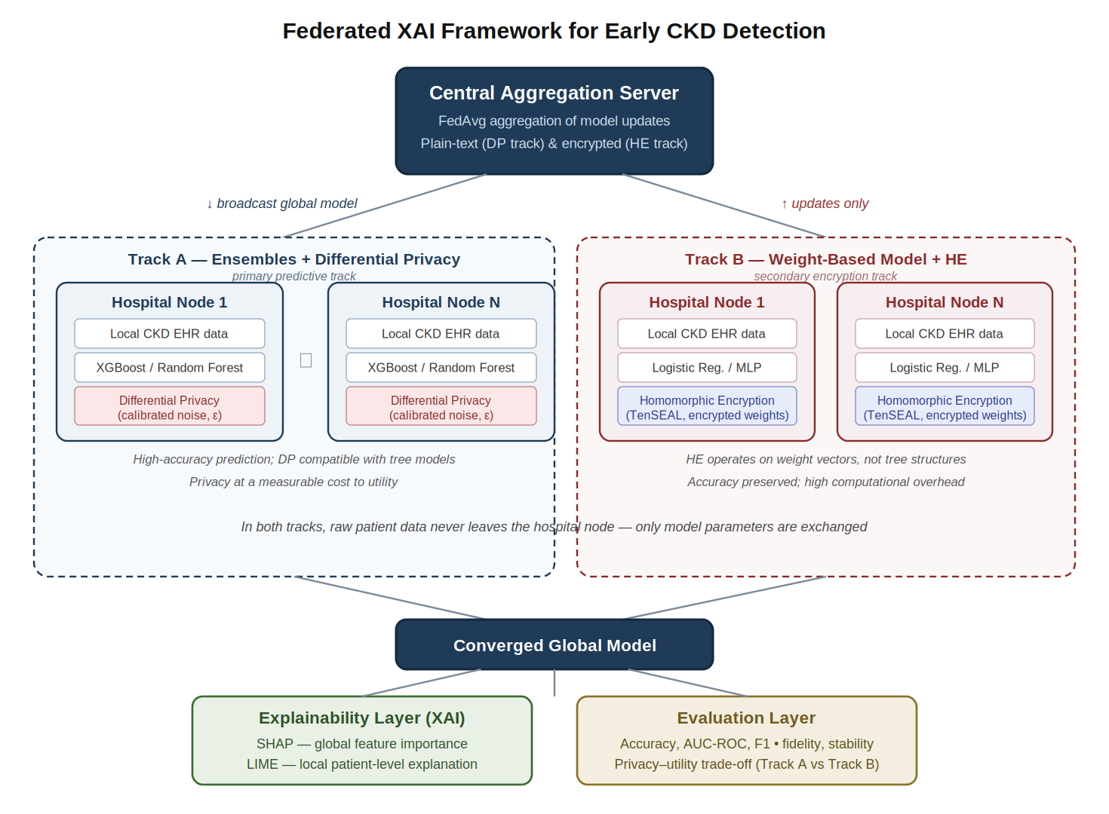
Figure 3.1.Federated XAI Framework for Early CKD Detection
Figure 3.1: Architecture of the proposed federated, explainable, and privacy-preserving framework for early CKD detection. The framework follows two tracks. Track A, the primary predictive track, trains ensemble models (XGBoost and Random Forest) across hospital nodes and protects model updates with Differential Privacy. Track B, a secondary track, applies Homomorphic Encryption to a weight-based model (logistic regression or MLP), since encryption operates on parameter vectors rather than tree structures. In both tracks, raw patient data never leaves the node; only model parameters are exchanged. The converged global model is interpreted through the explainability layer (SHAP and LIME) and assessed through the evaluation layer, including the cross-track privacy–utility analysis. The two-track design is explained in full in Section 3.7.

3.2 DATASET DESCRIPTION
The dataset used in this study is the Chronic Kidney Disease dataset originally contributed to the UCI Machine Learning Repository by Rubini, Soundarapandian and Eswaran (2015), obtained in comma-separated-value form from the Kaggle data-science platform. The data was collected over a period of approximately two months at a hospital in India and is among the most widely used benchmarks for CKD prediction research, which makes it particularly suitable for the present study because it allows the results to be compared directly with the large body of prior work reviewed in Chapter Two. The dataset is released under a Creative Commons Attribution 4.0 licence, permitting its use and adaptation for research provided appropriate credit is given.
The dataset comprises 400 patient records. As obtained, the file contains 26 columns: an id column added during conversion to CSV, which serves only as a row index and is removed during preprocessing; 24 clinical features; and a single target variable, classification, indicating whether each patient has chronic kidney disease (ckd) or not (notckd). The 24 features therefore correspond exactly to the standard UCI specification of 24 attributes plus one class label. The target distribution is imbalanced, with 250 records labelled as CKD and 150 as non-CKD, a point of importance that is addressed in the evaluation through the use of metrics beyond accuracy and, where appropriate, class-balancing techniques.
Of the 24 features, 14 are numerical and 10 are nominal (categorical). The features span the principal categories of clinical information used in the assessment of kidney function, namely demographic and vital measurements, blood and urine biochemistry, haematological indices, and recorded comorbidities. The complete set of features, their data types, and their clinical meaning is presented in Table 3.1.

Table 3.1 - Features of the CKD Dataset

# | Attribute | Code | Type | Description
1 | Age | age | Numerical | Patient age in years
2 | Blood Pressure | bp | Numerical | Blood pressure (mm/Hg)
3 | Specific Gravity | sg | Numerical | Specific gravity of urine (1.005, 1.010, 1.015, 1.020, 1.025)
4 | Albumin | al | Numerical | Albumin level (0–5)
5 | Sugar | su | Numerical | Sugar level (0–5)
6 | Red Blood Cells | rbc | Nominal | Red blood cells (normal / abnormal)
7 | Pus Cell | pc | Nominal | Pus cell (normal / abnormal)
8 | Pus Cell Clumps | pcc | Nominal | Pus cell clumps (present / notpresent)
9 | Bacteria | ba | Nominal | Bacteria (present / notpresent)
10 | Blood Glucose Random | bgr | Numerical | Random blood glucose (mgs/dl)
11 | Blood Urea | bu | Numerical | Blood urea (mgs/dl)
12 | Serum Creatinine | sc | Numerical | Serum creatinine (mgs/dl)
13 | Sodium | sod | Numerical | Sodium (mEq/L)
14 | Potassium | pot | Numerical | Potassium (mEq/L)
15 | Haemoglobin | hemo | Numerical | Haemoglobin (gms)
16 | Packed Cell Volume | pcv | Numerical | Packed cell volume
17 | White Blood Cell Count | wc | Numerical | White blood cell count (cells/cumm)
18 | Red Blood Cell Count | rc | Numerical | Red blood cell count (millions/cmm)
19 | Hypertension | htn | Nominal | Hypertension (yes / no)
20 | Diabetes Mellitus | dm | Nominal | Diabetes mellitus (yes / no)
21 | Coronary Artery Disease | cad | Nominal | Coronary artery disease (yes / no)
22 | Appetite | appet | Nominal | Appetite (good / poor)
23 | Pedal Edema | pe | Nominal | Pedal edema (yes / no)
24 | Anaemia | ane | Nominal | Anaemia (yes / no)
— | Class | classification | Target | Diagnosis (ckd / notckd)
The clinical relevance of these features aligns closely with the biomarkers identified in the literature as significant predictors of CKD. In particular, serum creatinine, blood urea, haemoglobin, packed cell volume, albumin, and specific gravity recur throughout the explainable-AI studies reviewed in Chapter Two as the most influential variables, and their presence in this dataset enables the explainability analysis of the present study to be validated against established clinical knowledge.
Finally, the dataset as obtained is not analysis-ready and exhibits several data-quality issues characteristic of real clinical records. A substantial number of values are missing across many of the features, reflecting tests that were not performed or results that were not recorded. In addition, the raw file contains formatting inconsistencies introduced during data entry and conversion, including stray whitespace and tab characters within categorical values (for example, trailing characters in entries such as "ckd" and "yes"), and several numerical columns that are stored as text rather than numeric types as a result. These issues are not a deficiency for the purposes of this study but rather a realistic feature of clinical data, and addressing them systematically forms the subject of the data preprocessing described in the following section.

3.3 DATA PREPROCESSING
Because the dataset as obtained is not in a form suitable for direct use, as established in the previous section, it undergoes a systematic preprocessing pipeline before any model training takes place. Preprocessing serves to correct data-quality issues, to render all features numerically usable, to address missing values, and to place the features on a common scale, thereby ensuring that the models learn from clean and consistent inputs. In the federated setting of this study, it is important to note that preprocessing is performed locally at each client node on its own partition of the data, so that no raw data is centralised at any stage; the procedure described here is applied identically at every node. The pipeline consists of five stages: data cleaning, removal of redundant columns, handling of missing values, encoding of categorical variables, and feature scaling, followed by feature selection.

3.3.1 DATA CLEANING AND TYPE CORRECTION
The first stage addresses the formatting inconsistencies noted in Section 3.2. Stray whitespace and tab characters embedded within categorical values, such as trailing characters in entries like "ckd" or "yes", are stripped so that each category is represented consistently; without this step, the same logical value would be treated as two distinct categories. Numerical columns that were stored as text as a consequence of these stray characters, including packed cell volume, white blood cell count, and red blood cell count, are converted to their correct numeric types. The target variable is standardized to two clean classes, ckd and notckd. This stage ensures that each feature is represented in a single, consistent form before further processing.

3.3.2 REMOVAL OF REDUNDANT COLUMNS
The id column, which serves only as a row index and carries no clinical or predictive information, is removed, as retaining it would introduce a meaningless identifier into the feature space. This leaves the 24 clinical features and the target variable for subsequent processing.

3.3.3 HANDLING OF MISSING VALUES
The dataset contains a substantial number of missing values across many features, reflecting the realistic incompleteness of clinical records. Rather than discarding incomplete records, which would substantially reduce an already small dataset of 400 instances and risk introducing bias, the missing values are imputed. A type-sensitive imputation strategy is adopted. For numerical features, missing values are filled using either median imputation or K-Nearest Neighbours (KNN) imputation, the median being preferred over the mean because it is robust to the outliers present in several of the biochemical features. For categorical features, missing values are imputed using the most frequent value (the mode) of the respective feature. This approach preserves the full set of 400 records while ensuring that no missing entries remain to disrupt model training. The choice of imputation method is treated as part of the experimental configuration, allowing its effect on performance to be assessed.

3.3.4 ENCODING OF CATEGORICAL VARIABLES
Machine-learning algorithms require numerical inputs, so the 10 nominal features must be converted into numeric form. The binary categorical features, such as hypertension, diabetes mellitus, coronary artery disease, pedal edema, anaemia, appetite, and the red-blood-cell and pus-cell indicators, are encoded using label encoding, which maps each of the two categories to the values 0 and 1. The target variable is likewise encoded, with ckd mapped to 1 and notckd mapped to 0. This produces a fully numerical feature matrix suitable for input to the predictive models.

3.3.5 FEATURE SCALING
The numerical features in the dataset span widely differing ranges; for example, age is measured in years, blood glucose in milligrams per decilitre, and serum creatinine in single-digit values. To prevent features with larger numerical ranges from dominating the learning process, the numerical features are standardised to a common scale. Normalisation is applied using either Min-Max scaling, which rescales values to the range between zero and one, or standardisation (z-score scaling), which transforms features to have zero mean and unit variance. While tree-based ensemble models such as XGBoost and Random Forest are themselves insensitive to feature scaling, scaling is nonetheless applied because the weight-based model on the secondary privacy track, namely logistic regression, and the distance- and gradient-based computations involved in the privacy mechanisms are sensitive to the relative magnitude of features.
3.3.6 FEATURE SELECTION
Following cleaning and transformation, feature selection is performed to identify the most informative subset of features, with the dual aim of reducing dimensionality and improving model interpretability and efficiency. Two complementary techniques are employed. Correlation analysis is used to examine the relationships between features and the target variable and to identify any highly inter-correlated features that contribute redundant information. In addition, Permutation Feature Importance (PFI) is used to rank the features according to the degree to which the model's performance depends on each, by measuring the drop in performance when each feature's values are randomly shuffled. The features identified as most important by these methods are expected to correspond to the clinically significant biomarkers discussed in Chapter Two, namely serum creatinine, haemoglobin, albumin, specific gravity, and packed cell volume, providing an early point of agreement between the data-driven analysis and established medical knowledge. The resulting processed and reduced dataset forms the input to the federated learning architecture described in the next section.

3.4 FEDERATED LEARNING ARCHITECTURE
The core of the proposed framework is a federated learning architecture that enables the collaborative training of a CKD prediction model across several simulated hospitals without centralising any patient data. This section describes the structure of that architecture, the manner in which the dataset is partitioned to emulate a multi-institutional environment, and the aggregation procedure by which local models are combined into a global model. The architecture realises the first objective of the study and provides the decentralised foundation on which the predictive, explainability, and privacy components are built.

3.4.1 SERVER–CLIENT STRUCTURE
The architecture follows the standard federated configuration of a single central aggregation server coordinating a number of client nodes, as illustrated in Figure 3.1. Each client represents a hospital and holds its own local partition of the CKD data, on which it trains a local copy of the model. The central server holds no patient data of its own; its role is to initialise the global model, to distribute it to the clients, and to aggregate the model updates returned by them. Communication between the server and clients is restricted to model parameters alone: at no point are raw patient records transmitted across the network. This separation between the data, which remains local, and the model, which travels, is the structural property that gives the architecture its privacy-preserving character.
In this study the federation is simulated on a single machine, with each client instantiated as a separate process operating on its own disjoint partition of the data. This simulation approach is consistent with the federated CKD studies reviewed in Chapter Two, such as those of Jahin et al. (2024) and Salmeron et al. (2023), and is a practical necessity given that access to genuine multi-hospital data is constrained by the very privacy barriers this study addresses. The number of clients is treated as a configurable parameter of the experiments; a baseline of four to five hospital nodes is adopted, consistent with comparable studies, and this value can be varied to examine the effect of the number of participants on model performance.

3.4.2 DATA PARTITIONING: IID AND NON-IID DISTRIBUTIONS
To emulate a multi-institutional setting, the preprocessed dataset is divided into disjoint partitions, one for each client, such that every record is held by exactly one hospital node. The manner in which this partitioning is performed is of central importance, because it determines the degree of statistical heterogeneity across clients, a factor identified in Chapter Two as one of the principal challenges of federated learning. Two partitioning schemes are therefore implemented and compared.
In the independent and identically distributed (IID) scheme, the data is shuffled and divided uniformly at random among the clients, so that each client receives a partition whose statistical distribution, including its balance of CKD and non-CKD cases, closely resembles that of every other client and of the dataset as a whole. This represents the idealised case in which all participating hospitals serve similar populations.
In the non-independent and identically distributed (non-IID) scheme, the data is partitioned so as to introduce deliberate heterogeneity between clients, reflecting the more realistic situation in which different hospitals serve different patient populations. This is achieved by skewing the distribution of the data across clients, for example by allocating differing proportions of CKD and non-CKD cases to different nodes, or by partitioning according to a label-based or Dirichlet-controlled distribution so that each client's data is statistically distinct. Evaluating the framework under both schemes allows the robustness of the federated model to realistic data heterogeneity to be assessed, in direct support of the study's examination of non-IID conditions.

3.4.3 MODEL AGGREGATION WITH FEDERATED AVERAGING
Once each client has trained its local model on its own partition, the resulting model updates are combined into an improved global model through the Federated Averaging (FedAvg) algorithm introduced in Chapter Two. Training proceeds over a series of communication rounds. At the start of each round, the server distributes the current global model to the participating clients; each client trains this model on its local data for a defined number of local epochs; the clients then return their updated parameters to the server; and the server aggregates these into a new global model by computing a weighted average, in which each client's contribution is weighted in proportion to the number of records it holds. This aggregation is expressed by Equation 2.1 introduced in the previous chapter, reproduced here as the operation performed by the server at each round:
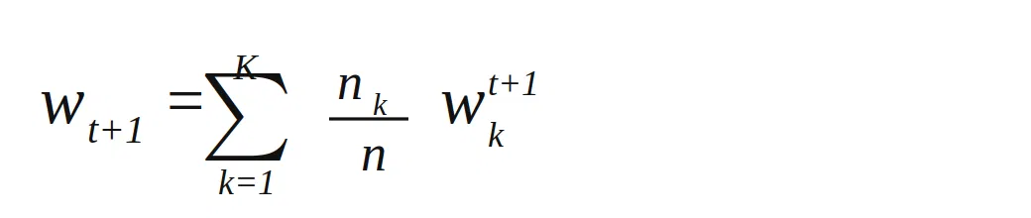
Figure 3.1 The FedAvg equation image
where the global parameters at round t + 1 are formed from the locally updated parameters of each of the K clients, weighted by the proportion of the total data that each client holds. This cycle of distribution, local training, and weighted aggregation repeats until the global model converges or a predetermined number of rounds is reached. The number of communication rounds and the number of local epochs per round are treated as configurable hyperparameters of the experiments. Because only averaged model parameters are exchanged, the procedure yields a single global model that benefits from the data of all participating hospitals while ensuring that no raw data ever leaves any individual node.

3.5 PREDICTIVE MODELS
This section describes the machine-learning models trained within the federated architecture. In keeping with the design established in Section 3.1, the framework employs two model tracks. The primary track uses ensemble tree-based models, namely XGBoost and Random Forest, which serve as the principal predictive engine of the system and are the focus of the accuracy results. A secondary track uses a weight-based model, logistic regression, which exists to support the homomorphic-encryption component of the privacy analysis. The rationale for this two-track design is set out below and developed further in Section 3.7.

3.5.1 PRIMARY TRACK: ENSEMBLE MODELS
The primary predictive models are XGBoost and Random Forest, selected for the reasons established in the literature review: ensemble tree-based methods consistently achieve strong performance on structured, tabular clinical data of the kind found in the CKD dataset, are robust to outliers and mixed data types, and have been shown to match or exceed more complex deep-learning models on datasets of this scale while remaining more efficient to train. These properties make them well suited to the resource-constrained, privacy-sensitive setting that this study addresses, and their relative interpretability complements the explainability analysis that follows.
Random Forest is an ensemble of decision trees constructed through bagging, in which each tree is trained on a bootstrap sample of the local data using a random subset of features, and the trees' outputs are combined by majority vote. Its key hyperparameters include the number of trees in the ensemble, the maximum depth of each tree, and the number of features considered at each split. XGBoost is a gradient-boosting ensemble in which trees are constructed sequentially, each correcting the errors of its predecessors, and is governed by hyperparameters including the number of boosting rounds, the learning rate, and the maximum tree depth. In the federated setting, each client trains the ensemble model on its own local partition during each communication round, and the resulting models are combined at the server as described in Section 3.4.
It is acknowledged that the aggregation of tree-based models in a federated setting differs fundamentally from the parameter averaging used for weight-based models, since decision trees are structural rather than parametric and cannot be averaged element-wise. The federated ensembles are therefore combined by size-weighted averaging of each client's predicted probabilities, the output-level analogue of the parameter weighting defined in Equation 2.1: each client's locally trained ensemble contributes its prediction in proportion to the size of its local partition, rather than its parameters being averaged directly. This structural property, that tree ensembles can be combined only at the level of their outputs and not their parameters, is also the reason that homomorphic encryption, which operates on numerical parameter vectors, cannot be applied directly to the ensemble track, motivating the secondary track described below.

3.5.2 SECONDARY TRACK: WEIGHT-BASED MODEL
The secondary track employs logistic regression, a linear model that estimates the probability of CKD as a function of a weighted combination of the input features. Logistic regression is chosen for this track because it is represented entirely by a vector of numerical weights, which can be averaged through Federated Averaging in the standard manner and, crucially, can be encrypted and aggregated under homomorphic encryption. This makes it the natural vehicle for demonstrating encryption-based privacy protection, which the ensemble models cannot structurally support.
The purpose of this track is not to compete with the ensemble models on predictive accuracy but to enable the privacy–utility analysis of Objective 5 to encompass both privacy mechanisms. By training logistic regression within the same federated architecture and on the same data partitions, the study is able to apply homomorphic encryption to a compatible model while applying differential privacy to the ensemble track, and thereby to analyse both privacy-enhancing technologies within a single, coherent federated framework. Where appropriate, a small multilayer perceptron may also be considered on this track as a weight-based alternative, since it shares the parametric structure that makes encryption feasible.

3.5.3 CENTRALISED BASELINE
In addition to the federated models, a centralised model is trained on the pooled dataset, without any federation or privacy mechanism, to serve as a performance reference. This baseline represents the conventional, non-privacy-preserving approach and provides the upper-bound benchmark against which the federated models are compared. The difference in performance between this centralised baseline and the federated models constitutes the "privacy cost" or "federation cost" quantified in the evaluation, a central element of the analysis carried out under Objective 5.

3.6 EXPLAINABILITY MODULE
Having established the predictive models, this section describes how their predictions are made interpretable, addressing the third objective of the study. As discussed in Chapter Two, the ensemble models that achieve the strongest predictive performance operate as opaque "black boxes," offering no insight into the reasoning behind their predictions. Since the clinical utility of a CKD prediction depends not only on its accuracy but on a clinician's ability to understand and trust it, an explainability module is integrated into the framework. This module is applied as a post-hoc layer to the converged global model, producing both global explanations, which describe the behaviour of the model across the whole patient population, and local explanations, which account for the prediction made for an individual patient. The two techniques employed, SHAP and LIME, were selected because they are model-agnostic, are extensively validated in the clinical literature, and together provide complementary global and local perspectives.

3.6.1 GLOBAL EXPLANATIONS WITH SHAP
SHAP is used to provide a global, population-level account of how the federated model arrives at its predictions. After the global model has converged, SHAP values are computed for the predictions across the dataset, attributing to each feature a contribution representing the magnitude and direction of its influence. For the tree-based models on the primary track, the TreeSHAP estimator is used, as it is computationally efficient and exact for ensemble tree models. Aggregating these values across all patients yields a global ranking of feature importance, which is presented through SHAP summary plots that show both the overall importance of each feature and the way in which high or low feature values push predictions towards or away from a diagnosis of CKD. Dependence plots are additionally used to examine how the model's output varies with individual features such as serum creatinine or haemoglobin. This global analysis serves a dual purpose: it identifies the clinical variables on which the model most relies, and it provides a means of validating the model against established medical knowledge, since agreement between the model's most influential features and the recognised clinical biomarkers of CKD constitutes evidence that the model has learned clinically sound patterns rather than spurious correlations.

3.6.2 LOCAL EXPLANATIONS WITH LIME
While SHAP provides the population-level view, LIME is used to generate explanations for individual predictions, of the kind that would accompany a single patient's risk assessment in clinical use. For a given patient, LIME constructs an interpretable local surrogate model in the neighbourhood of that patient's data and uses it to identify which features contributed most to that specific prediction, and in which direction. The result is a patient-level explanation report indicating, for example, that an elevated serum creatinine level and the presence of hypertension were the principal factors driving a high-risk prediction for a particular individual. Such case-by-case explanations are the form of interpretability most directly useful to a clinician at the point of care, as they make transparent the basis of each individual decision rather than the behaviour of the model in general. SHAP and LIME are thus applied in a complementary manner, the former establishing global trust in the model's overall logic and the latter supporting trust in individual predictions.

3.6.3 EXPLAINABILITY IN THE FEDERATED SETTING
A consideration specific to this study is that the explanations are generated for the converged global model, which has been trained across all participating hospitals, but the explanation process itself is carried out locally, using each client's own data, so that no raw data is centralised in order to produce the explanations. This preserves the privacy-preserving character of the framework throughout the interpretability stage. The integration of explainability into a federated model in this way is precisely the combination identified in Chapter Two as absent from the existing literature, in which interpretability has been demonstrated predominantly on centralised data; its provision here, without compromising data privacy, represents a central contribution of the study.

3.7 PRIVACY MECHANISMS
While the federated architecture of Section 3.4 ensures that raw patient data never leaves any hospital node, it was established in Chapter Two that the model updates exchanged during training can, under certain attacks, leak information about the underlying data. To close this residual gap, two privacy-enhancing technologies are integrated into the framework: Differential Privacy and Homomorphic Encryption. As set out in the two-track design of Sections 3.1 and 3.5, these are applied to the model tracks for which they are structurally suited, Differential Privacy to the ensemble track and Homomorphic Encryption to the weight-based track. Analysing both within a single federated framework, and measuring their respective effects on predictive accuracy and computational cost, constitutes the privacy–utility analysis of the study's fifth objective.

3.7.1 DIFFERENTIAL PRIVACY ON THE ENSEMBLE TRACK
Differential Privacy provides a formal, mathematical guarantee that the contribution of any single patient's record to the trained model is bounded, so that the presence or absence of that individual cannot be inferred from the model's outputs. A randomised mechanism is said to satisfy (ε, δ)-differential privacy if, for any two datasets differing in a single record, the probability of producing any given output differs by at most a factor governed by the privacy budget ε, with a small additive term δ. The parameter ε controls the strength of the guarantee: a smaller ε permits less variation between the two cases and therefore provides stronger privacy, at the cost of greater distortion of the model; a larger ε weakens the guarantee but preserves more of the model's utility.
In this study, Differential Privacy is applied to the ensemble track by introducing calibrated random noise into the training process. Noise drawn from a Gaussian or Laplace distribution, scaled according to the sensitivity of the computation and the chosen privacy budget, is added to the model updates before they contribute to the global model. The privacy budget ε is treated as the principal experimental variable of the privacy analysis: the framework is trained and evaluated at several values of ε, ranging from weaker to stronger privacy settings, so that the relationship between the strength of the privacy guarantee and the resulting predictive performance can be quantified. This produces the privacy–utility trade-off curve that is a central result of the study, expressing in measurable terms how much accuracy is sacrificed as privacy is tightened.

3.7.2 HOMOMORPHIC ENCRYPTION ON THE WEIGHT-BASED TRACK
Homomorphic Encryption protects privacy through cryptography rather than through the addition of noise. It permits computation to be performed directly on encrypted values, such that the result obtained after decryption is identical to the result that would have been obtained from the same computation on the unencrypted data. Applied to federated learning, this allows each client to encrypt its model parameters before transmitting them, and allows the server to perform the aggregation while the parameters remain encrypted, so that the server never observes any individual client's parameters in unencrypted form. Because the result of the encrypted aggregation, once decrypted, is mathematically identical to ordinary aggregation, this protection introduces no noise and therefore, in principle, no loss of predictive accuracy.
In this study, Homomorphic Encryption is implemented on the weight-based track using the TenSEAL library, which provides an accessible implementation of homomorphic encryption schemes suitable for machine learning. The CKKS scheme is employed, as it supports approximate arithmetic on real numbers and is the scheme best suited to the floating-point parameters of a machine-learning model. The procedure operates as follows: an encryption context defining the cryptographic parameters is established; each client encrypts its locally trained model weights under this scheme; the server aggregates the encrypted weights through the additive operation that Federated Averaging requires; and the aggregated result is decrypted to update the global model. Because Homomorphic Encryption preserves accuracy but imposes a substantial computational and communication overhead, the evaluation of this mechanism focuses not on any loss of accuracy but on the cost it incurs, measured in terms of the additional computation and communication time relative to the unencrypted baseline.

3.7.3 SUMMARY OF THE PRIVACY–UTILITY ANALYSIS
Taken together, the two mechanisms allow the framework to be examined across the full privacy spectrum. Differential Privacy, applied to the high-performing ensemble models, trades a quantifiable amount of accuracy for a tunable, formally guaranteed level of privacy. Homomorphic Encryption, applied to the weight-based model, preserves accuracy exactly but at a quantifiable computational cost. By measuring accuracy loss as a function of the privacy budget on the one hand, and computational overhead on the other, the study characterises the privacy–utility–efficiency trade-off that distinguishes the two approaches, providing the empirical basis for the fifth objective and for the guidance offered to practitioners in the concluding chapter.

3.8 EVALUATION METRICS
The framework is evaluated along three dimensions, corresponding to the three properties it is designed to deliver: predictive performance, interpretability, and privacy. This multidimensional evaluation reflects the fourth and fifth objectives of the study, and the metrics used in each dimension are described below. Reporting performance across all three dimensions, rather than on accuracy alone, is essential because a model that is accurate but uninterpretable, or private but inaccurate, would fail to meet the aims of the study.

3.8.1 PREDICTIVE PERFORMANCE METRICS
The predictive performance of the models is assessed using the standard metrics for binary classification, derived from the counts of true positives, true negatives, false positives, and false negatives. Given the class imbalance noted in Section 3.2, where CKD cases outnumber non-CKD cases, accuracy alone would be a misleading measure, and a range of complementary metrics is therefore reported.
Accuracy measures the overall proportion of correct predictions. Precision measures the proportion of patients predicted to have CKD who genuinely have it, while recall, also termed sensitivity, measures the proportion of genuine CKD cases that the model correctly identifies. Recall is of particular clinical importance in this context, since failing to identify a patient who has CKD, a false negative, is a more serious error than a false alarm, and a screening tool for early detection must above all avoid missing true cases. Specificity measures the proportion of non-CKD patients correctly identified as such. The F1-score, the harmonic mean of precision and recall, provides a single balanced measure that is robust to class imbalance. Finally, the area under the receiver operating characteristic curve (AUC-ROC) summarises the model's ability to discriminate between the two classes across all decision thresholds, with a value of one representing perfect discrimination and 0.5 representing no better than chance. Together these metrics provide a complete picture of predictive performance and allow the federated models, the centralised baseline, and the models under each privacy setting to be compared on a consistent basis.

3.8.2 INTERPRETABILITY METRICS
Beyond predictive performance, the quality of the explanations produced by the explainability module is itself evaluated, in recognition that an explanation is only valuable if it faithfully and reliably reflects the model's behaviour. Two properties are assessed. Fidelity measures the degree to which the explanations correspond to the actual behaviour of the underlying model, that is, whether the features that an explanation identifies as influential genuinely are the features driving the model's predictions; a high-fidelity explanation is one that accurately represents the model rather than merely offering a plausible-seeming account. Stability measures the consistency of the explanations, that is, whether applying the explanation method repeatedly, or to very similar inputs, yields similar results; this is of particular relevance to LIME, which, as noted in Chapter Two, can produce variable explanations because of its reliance on random perturbation. In addition to these quantitative properties, the clinical validity of the explanations is assessed qualitatively, by examining whether the features identified as most influential align with the recognised clinical biomarkers of CKD, as discussed in Section 3.6.

3.8.3 PRIVACY AND EFFICIENCY METRICS
The privacy dimension of the evaluation, central to the fifth objective, is assessed through the effect of each privacy mechanism on the framework. For Differential Privacy, the key measure is the privacy cost, defined as the reduction in predictive performance, principally accuracy and AUC-ROC, incurred at a given privacy budget ε relative to the model trained without differential privacy. By measuring this cost across a range of ε values, the privacy–utility trade-off is quantified. A related measure is the federation cost, the difference in performance between the centralised baseline of Section 3.5 and the federated model without added privacy, which isolates the effect of decentralisation itself. For Homomorphic Encryption, where accuracy is preserved by construction, the relevant measure is instead the computational overhead, quantified as the additional training and communication time required when encryption is applied, relative to the unencrypted weight-based model. Reporting these measures together enables the privacy–utility–efficiency trade-off described in Section 3.7 to be characterised empirically, completing the evaluation of the framework.

3.9 IMPLEMENTATION TOOLS AND EXPERIMENTAL SETUP
This section specifies the software and hardware environment in which the framework is implemented and the experimental configuration under which it is evaluated, concluding with the measures taken to ensure that the results are reproducible.

3.9.1 SOFTWARE TOOLS AND LIBRARIES
The framework is implemented in Python, the standard language for machine-learning research, which provides mature libraries for every component of the system. The principal tools are as follows.
The general data handling, preprocessing, and evaluation are carried out using pandas and NumPy for data manipulation and scikit-learn (Pedregosa et al., 2011), which provides the implementations of Random Forest, logistic regression, the preprocessing utilities such as imputation and scaling, and the evaluation metrics. The gradient-boosting model is provided by the dedicated XGBoost library.
The federated learning is implemented as a custom simulation built directly on scikit-learn and XGBoost, in which each client and the server are realised as separate Python components operating on their own disjoint data partitions, coordinated by a lightweight orchestration layer that reproduces the standard federated communication pattern of distribution, local training, and aggregation. Federated Averaging is implemented directly: as size-weighted averaging of client outputs for the ensemble track, and size-weighted averaging of client parameters for the weight-based track, following Equation 2.1. This custom implementation was preferred over a general-purpose federated-learning framework because it allows the aggregation logic appropriate to each model track, output averaging for the structurally non-parametric tree ensembles and parameter averaging for the weight-based model, to be implemented explicitly and verified directly, while remaining fully faithful to the server–client communication pattern of a real federated deployment.
The explainability module is implemented using the SHAP and LIME libraries, which provide the respective interpretability methods together with their associated visualisation utilities, including the SHAP summary and dependence plots. Visualisation of results more generally is produced using Matplotlib and Seaborn.
The privacy mechanisms draw on two further libraries. Differential Privacy is implemented through the addition of calibrated noise to the training process, supported where appropriate by an established differential-privacy library. Homomorphic Encryption is implemented using TenSEAL (Benaissa et al., 2021), a library for performing homomorphic encryption on tensors that provides an accessible implementation of the CKKS scheme suitable for encrypting and aggregating model parameters. The specific versions of these libraries used in the implementation are recorded to support reproducibility, as described in Section 3.9.4.

3.9.2 HARDWARE ENVIRONMENT
The experiments are conducted on a standard computing environment, with the federated setup simulated on a single machine on which each client and the server operate as separate processes. Because the dataset is modest in size and the primary models are computationally efficient ensemble methods, the predictive and explainability components do not require specialised hardware such as a graphics processing unit. The homomorphic-encryption experiments are the most computationally demanding part of the study, and the additional time they require is itself one of the quantities measured, as described in Section 3.8; the hardware configuration is therefore recorded so that these timing results can be interpreted in context.

3.9.3 EXPERIMENTAL CONFIGURATION
The evaluation is structured as a series of controlled experiments designed to address the study's objectives in turn. A centralised model is first trained on the pooled data to establish the baseline performance against which the federated models are compared. The federated models are then trained under both the IID and non-IID partitioning schemes described in Section 3.4, allowing the effect of data heterogeneity to be assessed. The privacy experiments are then conducted: the ensemble track is trained at a range of differential-privacy budgets (several values of ε) to trace the privacy–utility trade-off, and the weight-based track is trained with and without homomorphic encryption to measure the computational overhead of encryption. Throughout, the data is divided into training and testing sets, and cross-validation is used where appropriate to ensure that the reported performance is a reliable estimate rather than an artefact of a particular split. The key configurable parameters of the experiments, namely the number of clients, the number of communication rounds, the number of local epochs, the model hyperparameters, and the privacy budgets, are recorded for each experiment.

3.9.4 REPRODUCIBILITY
To ensure that the results of the study can be reproduced, several measures are adopted. All sources of randomness, including data shuffling, data partitioning, train-test splitting, and model initialisation, are controlled through fixed random seeds, so that each experiment yields the same result when repeated. The exact versions of all software libraries are recorded, since the behaviour of machine-learning and cryptographic libraries can change between releases. The values of all configurable parameters are documented for every experiment, as noted above. Finally, the preprocessing pipeline, the model configurations, and the experimental procedures are described in sufficient detail in this chapter that the study could be independently repeated. Together these measures ensure that the findings presented in the following chapter rest on a transparent and reproducible foundation.

CHAPTER FOUR

RESULTS AND DISCUSSION

4.0 INTRODUCTION
This chapter presents and discusses the results obtained from the framework described in Chapter Three, structured around the three-dimensional evaluation established in Section 3.8, namely predictive performance, interpretability, and privacy and efficiency, and organised so as to address each of the study's five objectives in turn. Section 4.1 reports the performance of the centralised baseline models, against which every subsequent result is compared. Section 4.2 presents the performance of the federated models under both IID and non-IID partitioning, together with the federation cost that decentralisation incurs, for the primary ensemble track and the secondary weight-based track alike. Section 4.3 reports the explainability outputs produced by SHAP and LIME and examines their agreement with established clinical knowledge of Chronic Kidney Disease. Section 4.4 presents the central contribution of the study, the empirical privacy–utility–efficiency analysis comparing Differential Privacy on the ensemble track with Homomorphic Encryption on the weight-based track. Section 4.5 draws these results together against the study's five objectives, Section 4.6 discusses the findings in relation to the related work reviewed in Chapter Two and the research gap it identified, and Section 4.7 sets out the limitations that bear on the interpretation of the results. Throughout, unless otherwise stated, experiments are repeated across ten random seeds, following the reproducibility measures set out in Section 3.9.4, so that reported values represent a mean and standard deviation rather than the outcome of a single run.

4.1 CENTRALISED BASELINE PERFORMANCE
As established in Section 3.5.3, a centralised model trained on the pooled, non-partitioned dataset provides the performance reference against which the federated results of Section 4.2 and the privacy-constrained results of Section 4.4 are subsequently compared. Three models were trained in this centralised configuration: Random Forest and XGBoost, the primary ensemble track defined in Section 3.5.1, and Logistic Regression, the secondary weight-based track defined in Section 3.5.2. Each model was evaluated by five-fold cross-validation on the training data and by the full metric suite of Section 3.8.1 on the held-out test set. The results are summarised in Table 4.1.
Table 4.1 - Centralised Baseline Performance
Model | CV Accuracy (mean ± SD) | Test Accuracy | Precision | Recall | Specificity | F1-Score | AUC-ROC
Random Forest | 0.9906 ± 0.0125 | 1.0000 | 1.0000 | 1.0000 | 1.0000 | 1.0000 | 1.0000
XGBoost | 0.9844 ± 0.0171 | 0.9875 | 1.0000 | 0.9800 | 1.0000 | 0.9899 | 1.0000
Logistic Regression | 0.9906 ± 0.0125 | 0.9875 | 1.0000 | 0.9800 | 1.0000 | 0.9899 | 1.0000
All three models achieved near-perfect performance on both the cross-validated training data and the held-out test set. Random Forest achieved a perfect test accuracy, precision, recall, specificity, F1-score, and AUC-ROC of 1.0000; XGBoost and Logistic Regression each achieved a test accuracy of 0.9875, with a single false negative accounting for the recall of 0.9800 recorded by both models. Because recall is, as noted in Section 3.8.1, the clinically decisive metric for a screening tool of this kind, it is notable that even the weaker of the three models missed only one CKD case in the entire test set, and that this single error was consistent across both non-ensemble and boosted-ensemble model families rather than being specific to one algorithm.
These results are consistent with, rather than exceptional relative to, the body of prior work surveyed in Section 2.8. Reported accuracies for the same UCI CKD dataset cluster tightly around this range: Poonia et al. (2022) obtained an accuracy of 98.75 per cent with an optimised logistic regression model, a figure matched almost exactly by the Logistic Regression result reported here, while Qin et al. (2020) and Khalid et al. (2023) reported accuracies of 99.83 and 100 per cent respectively using ensemble and hybrid classifiers. As anticipated in the scope and limitations set out in Section 1.6, this consistency across independent studies and model families is attributable principally to the small size and high class separability of the dataset itself, four hundred records whose clinical features distinguish the two classes with unusual clarity, rather than to any particular superiority of the models applied. This attribution is revisited in Section 4.7, and it is precisely because centralised accuracy on this dataset is already close to its ceiling that the more informative comparisons in this chapter are relative ones, the federation cost of Section 4.2 and the privacy cost of Section 4.4, rather than the absolute accuracy figures reported here.

4.2 FEDERATED LEARNING PERFORMANCE
This section reports the performance of the models described in Section 3.5 when trained under the federated architecture of Section 3.4, across the five simulated hospital nodes and under both the IID and non-IID partitioning schemes. In keeping with the reproducibility measures of Section 3.9.4, every result in this section is obtained across ten independent random seeds, each seed generating a fresh stratified train/test split and a fresh partition of the training data among the five clients, so that the figures reported are a mean and standard deviation across ten complete federated training runs rather than a single realisation. This addresses directly the concern, raised in Section 2.5.2, that a federated result obtained from a single arbitrary partition may reflect the particular partition drawn as much as the underlying robustness of the method.

4.2.1 Ensemble Models Under IID and Non-IID Partitioning
Random Forest and XGBoost were each trained under three partitioning schemes: the independent and identically distributed (IID) scheme of Section 3.4.2, in which every client's data closely resembles the overall population; a non-IID scheme with equal client sizes but Dirichlet-skewed class proportions, isolating the effect of distributional heterogeneity from that of differing client sizes; and a fully non-IID scheme in which both the class distribution and the size of each client's partition vary. The results, together with the centralised baseline of Section 4.1 for reference, are presented in Table 4.2.
Table 4.2 - Federated Learning Performance: Centralised vs Federated (10-seed mean ± SD)
Model | Partition Scheme | Accuracy | Recall | AUC-ROC
Random Forest | Centralised | 1.0000 | 1.0000 | 1.0000
 | IID | 0.9862 ± 0.0088 | 0.9900 ± 0.0100 | 0.9993
 | Non-IID (equal size) | 0.9925 ± 0.0083 | 0.9960 ± 0.0080 | 0.9997
 | Non-IID | 0.9925 ± 0.0100 | 0.9980 ± 0.0060 | 0.9994
XGBoost | Centralised | 0.9875 | 0.9800 | 1.0000
 | IID | 0.9613 ± 0.0247 | 0.9620 ± 0.0316 | 0.9963
 | Non-IID (equal size) | 0.9663 ± 0.0210 | 0.9720 ± 0.0271 | 0.9963
 | Non-IID | 0.9763 ± 0.0142 | 0.9880 ± 0.0133 | 0.9981
Across both models, the mean accuracy recorded under every partitioning scheme falls within one standard deviation of every other scheme for the same model: for Random Forest, the difference between the lowest mean (0.9862 under IID) and the highest (0.9925 under both non-IID variants) is 0.0063, smaller than the standard deviation of either figure, and the equivalent range for XGBoost, 0.9613 to 0.9763, is likewise smaller than the standard deviation of the IID result. Neither model shows the systematic degradation under non-IID partitioning that the literature reviewed in Section 2.5.2 identifies as the characteristic risk of statistical heterogeneity in federated learning; if anything, both models recorded marginally higher mean accuracy under the non-IID schemes than under IID, though this difference is not distinguishable from noise given the overlapping standard deviations. The most defensible reading of this result, and the one adopted here, is that the federated ensemble models are robust to the partitioning scheme examined on this dataset, a robustness attributable to the same high class separability discussed in Section 4.1 rather than to any inherent insensitivity of Federated Averaging to non-IID data in general. This qualification is returned to in Section 4.7.

4.2.2 Federation Cost
The federation cost, defined in Section 3.8.3 as the difference between the centralised accuracy of Section 4.1 and the corresponding federated accuracy, isolates the effect of decentralisation itself from any effect of data heterogeneity. These costs, for every model and partitioning scheme, are set out in Table 4.3.
Table 4.3 - Federation Cost (Centralised Accuracy − Federated Accuracy)
Model | Partition Scheme | Federation Cost
Random Forest | IID | +0.0138
Random Forest | Non-IID (equal size) | +0.0075
Random Forest | Non-IID | +0.0075
XGBoost | IID | +0.0262
XGBoost | Non-IID (equal size) | +0.0212
XGBoost | Non-IID | +0.0112
Logistic Regression | FedAvg (IID) | +0.0012
The federation cost is modest throughout, never exceeding 2.62 percentage points and, for Random Forest, remaining below 1.4 percentage points under every scheme. XGBoost consistently pays a somewhat larger federation cost than Random Forest, a pattern plausibly connected to the difference between the two ensembling strategies described in Section 2.3.1: Random Forest's bagged trees are each trained independently on a bootstrap sample, so training them on a smaller local partition changes little about the character of any individual tree, whereas XGBoost's trees are built sequentially, each correcting the residual error of its predecessors, a process more sensitive to the reduced sample size available at a single client before the size-weighted output aggregation of Section 3.5.1 recombines the clients' contributions. In both cases, the federation cost is small enough, relative to the near-ceiling centralised accuracy reported in Section 4.1, to support the conclusion that the decentralisation required by Objective 1 is achieved here at a limited and quantifiable cost to predictive performance.

4.2.3 FedAvg Logistic Regression: Convergence and Federation Cost
The secondary, weight-based track defined in Section 3.5.2 was trained by genuine iterative Federated Averaging, in which the server distributes a global weight vector, each client advances it by local stochastic gradient descent, and the server size-weighted-averages the resulting client parameters directly, following Equation 2.1 exactly rather than the output-level analogue used for the ensemble track. This distinction matters for two reasons: it is a direct empirical test of the two-track design established in Section 3.5, since a weight-based model can be aggregated in the manner FedAvg originally specifies, and it produces the converged global weight vector on which the Homomorphic Encryption analysis of Section 4.4.2 depends. Training proceeded for twenty communication rounds under the IID partitioning scheme; the resulting convergence, for the base random seed, is shown in Figure 4.1.
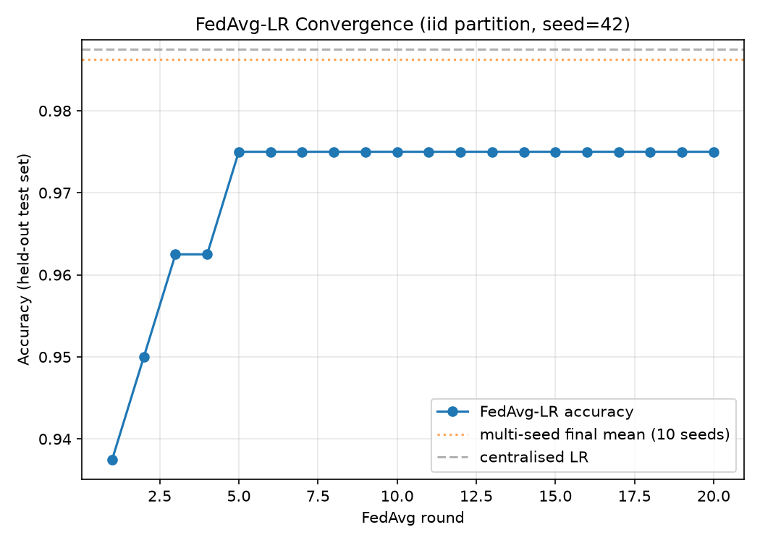
Figure 4.1: FedAvg Logistic Regression convergence over twenty communication rounds (IID partition, seed 42), against the multi-seed final-round mean and the centralised Logistic Regression baseline.
The global model accuracy rises from 0.9375 after the first round to 0.9750 by the fifth round and remains stable at that level for the remaining fifteen rounds, indicating that convergence is reached well within the twenty-round budget. Repeating this experiment across ten seeds, with a fresh stratified split and a fresh partition drawn for each, yields a final-round accuracy of 0.9863 ± 0.0131, a recall of 0.9780 ± 0.0209, and an AUC-ROC of 1.0000 ± 0.0000. Against the centralised Logistic Regression baseline of 0.9875 reported in Table 4.1, this represents a federation cost of only 0.0012, the smallest of any model or track examined in this study, and consistent with the theoretical expectation that true parameter-level FedAvg on a convex, weight-based model should approximate its centralised counterpart more closely than the output-level aggregation necessary for the structurally non-parametric tree ensembles. This result both satisfies Objective 1 for the secondary track and establishes the plaintext reference against which the computational overhead of Homomorphic Encryption is measured in Section 4.4.2.

4.3 EXPLAINABILITY RESULTS
This section reports the outputs of the explainability module described in Section 3.6, addressing Objective 3 directly and providing the qualitative evidence for the interpretability dimension of Objective 4. SHAP and LIME were applied to the converged XGBoost model, TreeSHAP being used for the global explanation in accordance with Section 3.6.1, exactly as it is exact and efficient for tree ensembles rather than an approximation, as it would be for a model of unrestricted architecture.

4.3.1 Global Explanations with SHAP
Aggregating SHAP values across the held-out test set yields a global ranking of feature importance, presented as mean absolute SHAP value in Table 4.4 and shown visually as a beeswarm summary plot in Figure 4.2 and a bar chart in Figure 4.3.
Table 4.4 - Global Feature Importance (Mean |SHAP Value|, XGBoost)
Rank | Feature | Code | Mean |SHAP|
1 | Haemoglobin | hemo | 2.5245
2 | Specific Gravity | sg | 1.3111
3 | Serum Creatinine | sc | 1.1256
4 | Albumin | al | 0.6916
5 | Age | age | 0.4647
6 | Hypertension | htn | 0.4081
7 | Red Blood Cell Count | rc | 0.2653
8 | Blood Glucose Random | bgr | 0.2039
9 | White Blood Cell Count | wc | 0.1938
10 | Sodium | sod | 0.1592
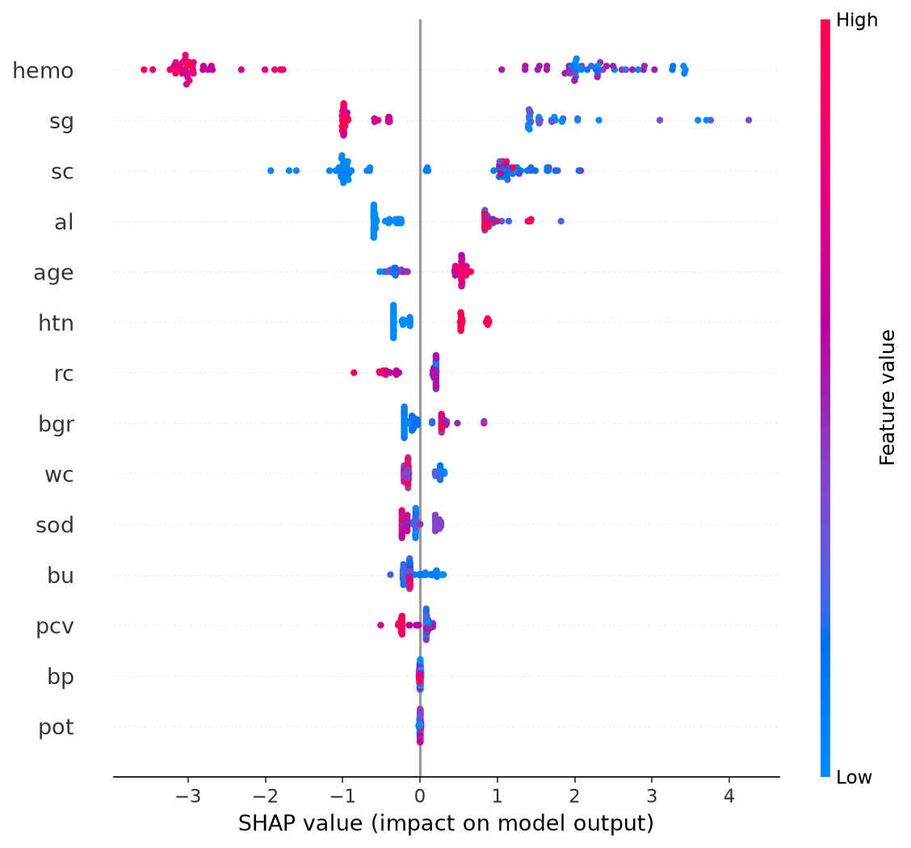
Figure 4.2: SHAP summary (beeswarm) plot for the XGBoost model. Each point is one test-set patient; position on the horizontal axis is that patient's SHAP value for the feature, and colour encodes the patient's value for that feature (red = high, blue = low).
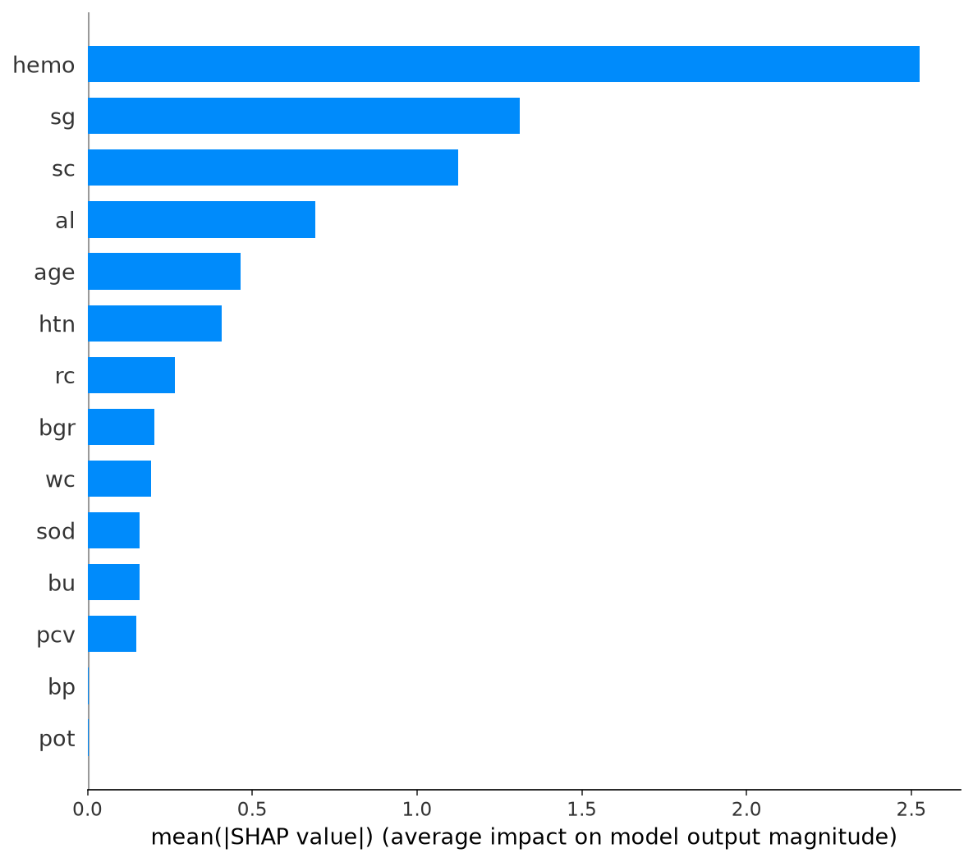
Figure 4.3: Global feature importance for the XGBoost model, ranked by mean absolute SHAP value.
Haemoglobin is by a wide margin the most influential feature, with a mean absolute SHAP value nearly double that of the second-ranked feature, specific gravity, which is in turn followed closely by serum creatinine and albumin; together these four features form a distinct top tier, separated from age, hypertension, and the remaining features by a marked drop in magnitude. Beyond confirming which features the model relies upon most, the beeswarm plot of Figure 4.2 reveals the direction of each feature's influence, and this directionality is, feature by feature, exactly what clinical knowledge of CKD would predict. Low haemoglobin values (blue) carry strongly positive SHAP values, pushing the prediction towards CKD, while high haemoglobin values (red) push strongly away from it, consistent with anaemia being a well-established consequence of declining kidney function as the diseased kidney loses its capacity to produce erythropoietin. Low specific gravity likewise pushes towards CKD, consistent with the reduced urine-concentrating capacity of a failing kidney; high serum creatinine and high albumin (indicating proteinuria) both push towards CKD, consistent with their established role as the two core diagnostic measurements described in Section 2.2.2; and the presence of hypertension pushes towards CKD, consistent with hypertension's role, alongside diabetes, as a principal driver of the disease as discussed in Section 2.1.
This pattern directly satisfies the validation criterion set out in Section 3.6.1: the features the model has learned to rely upon most heavily, and the direction in which each influences its predictions, correspond to recognised CKD biomarkers rather than to spurious correlations. It also corroborates the explainable-AI literature reviewed in Section 2.6.3 directly rather than merely by analogy. Ahmed et al. (2024) identified haemoglobin, albumin, serum creatinine, and estimated glomerular filtration rate as the most influential SHAP features across the CKD studies they reviewed, a set that matches four of the five highest-ranked features in Table 4.4 exactly. Haque et al. (2025), working with a fine-tuned XGBoost model on the same UCI dataset, likewise identified specific gravity and haemoglobin as the two most important features, matching the first two ranks in Table 4.4 precisely. This convergence, across independent studies using different implementations and in one case a different dataset entirely, is strong evidence that the federated model has learned clinically grounded patterns rather than artefacts specific to a particular training run.

4.3.2 Local Explanations with LIME
Where SHAP characterises the model's behaviour across the population, LIME produces the patient-level explanation report described in Section 3.6.2, of the kind that would accompany an individual risk assessment in clinical use. Two contrasting cases from the five patients explained are presented here as illustrations, one for which the model predicted the absence of CKD and one for which it predicted its presence.
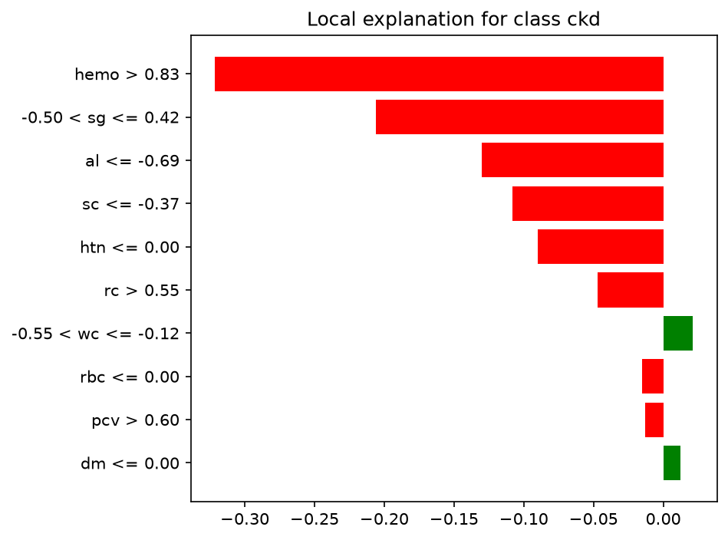
Figure 4.4: LIME local explanation for a test-set patient predicted not to have CKD. Bars extending left (red) reduce the predicted probability of CKD.
For the first patient, the explanation is dominated by an above-average haemoglobin reading, which alone accounts for the largest single contribution away from a CKD prediction, together with a moderate specific gravity, a below-average albumin reading, a below-average serum creatinine reading, and the absence of hypertension. Each of these five leading features, individually, is a normal or protective clinical finding, and together they form a coherent, low-risk biomarker profile consistent with the model's prediction.
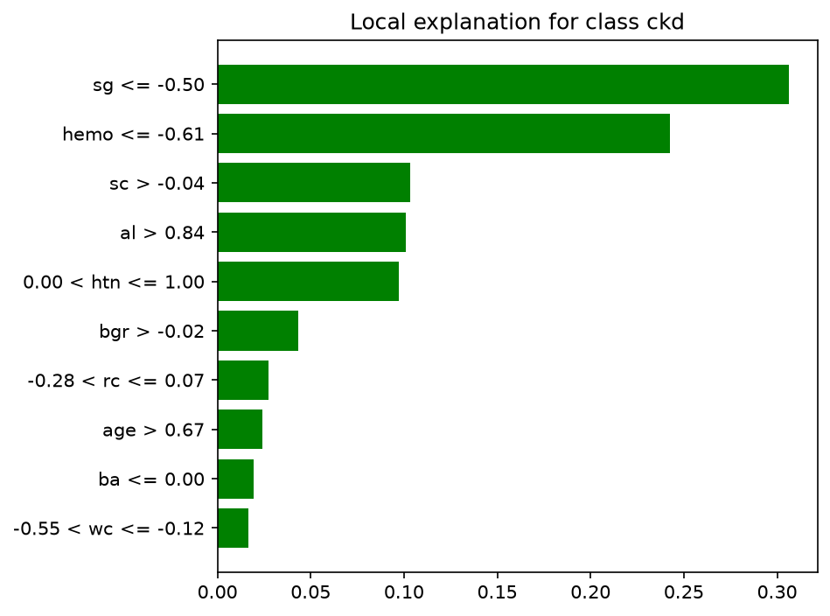
Figure 4.5: LIME local explanation for a test-set patient predicted to have CKD. Bars extending right (green) increase the predicted probability of CKD.
For the second patient, the explanation is led by a markedly low specific gravity and a markedly low haemoglobin reading, followed by an elevated serum creatinine reading, an elevated albumin reading, and the presence of hypertension. This is, feature for feature, the inverse of the first patient's profile and corresponds closely to the classical clinical presentation of CKD described in Section 2.2.2. Notably, the same five features, haemoglobin, specific gravity, serum creatinine, albumin, and hypertension, dominate both patients' local explanations and, in the same order of prominence, the global ranking of Table 4.4, indicating that the population-level patterns SHAP identifies are not merely an aggregate artefact but are actually present, and clinically legible, in individual predictions.

4.3.3 Clinical Validation and Interpretability Metrics
Section 3.8.2 identifies two properties by which the quality of the explanations themselves, as distinct from the predictions they explain, is assessed: fidelity, the degree to which an explanation corresponds to the actual local behaviour of the model, and stability, the consistency of an explanation under repetition. Both were measured directly for LIME, the method to which they are most pertinent, since a linear surrogate fitted to a randomly sampled local neighbourhood is, by construction, only an approximation of the underlying model, and since Section 2.6.2 identifies instability under repeated perturbation as LIME's principal recognised weakness. Fidelity was measured as the R² of LIME's local linear surrogate against the XGBoost model's own predictions within the perturbed neighbourhood of each patient. Stability was measured by repeating the LIME explanation for each patient five times, each with an independent random seed, and computing the Jaccard similarity of the top-five most influential features between every pair of repeats; a value of 1.0 indicates that the same five features were identified as most influential in every repeat, and a value of 0.0 that no two repeats agreed on any of the five. The results, for the five patients explained in Section 4.3.2, are reported in Table 4.5.
Table 4.5 - LIME Fidelity and Stability, per Patient (XGBoost)
Patient | Fidelity (R²) | Stability (Jaccard, top-5)
1 | 0.335 | 1.000
2 | 0.345 | 1.000
3 | 0.350 | 1.000
4 | 0.276 | 1.000
5 | 0.189 | 1.000
Mean ± SD | 0.299 ± 0.062 | 1.000 ± 0.000
The two properties diverge sharply, and the divergence is itself informative. Stability is perfect for every patient: across five independent repetitions with different random perturbation seeds, the same five features were identified as most influential every time, for every patient. This is a direct empirical test of the weakness Section 2.6.2 attributes to LIME, and on this framework and this dataset, that weakness did not materialise. The most plausible explanation lies in the same property that has recurred throughout this chapter: the marked separation, evident in Table 4.4 and Figure 4.3, between a small top tier of dominant features, haemoglobin, specific gravity, serum creatinine, and albumin, and the remaining features. When a handful of features so heavily outweigh the rest, the particular random sample of perturbed neighbours drawn by LIME has little opportunity to alter which features rank highest, even though the precise numerical weight assigned to each feature may still vary between repeats. Fidelity, by contrast, is modest, with a mean R² of 0.299 and a low of 0.189 for the fifth patient, indicating that LIME's simple linear surrogate captures under a third of the local variation in the XGBoost model's behaviour on average. This should temper how literally the explanations of Section 4.3.2 are read: the identity and direction of the leading features are highly reproducible, and, as Section 4.3.2 showed, clinically coherent, but the precise magnitude LIME assigns to each feature's contribution is a comparatively loose approximation of the underlying gradient-boosted decision surface, which is unsurprising given the sharp, high-order feature interactions that a boosted tree ensemble is capable of representing and that a linear surrogate, by construction, cannot. Taken together, Table 4.5 supports a specific and defensible claim: LIME reliably identifies which biomarkers drive an individual prediction and in which direction, which is the information of practical use to a clinician, considerably more reliably than it quantifies by how much.
This measured, patient-level evidence complements the population-level clinical validation of Section 4.3.1 and the qualitative case comparison of Section 4.3.2. Together, the three satisfy Objective 3 and provide the interpretability component of Objective 4: the framework produces explanations that are stable, that are grounded in features with clear clinical meaning, and whose principal limitation, a moderate fidelity ceiling on the local surrogate used by LIME specifically, is quantified rather than assumed.

4.4 PRIVACY-UTILITY-EFFICIENCY TRADE-OFF
This section presents the central empirical contribution of the study, addressing Objective 5 and the research gap identified in Section 2.9: an explicit, quantified comparison of Differential Privacy and Homomorphic Encryption within a single federated, interpretable, ensemble-based CKD framework. As established in Section 3.7, the two mechanisms are applied to the two model tracks for which each is structurally suited, Differential Privacy to the ensemble track and Homomorphic Encryption to the weight-based track, so the comparison that follows is a cross-track one: it asks not which mechanism is better in the abstract, but what kind of cost each imposes when applied to the part of the framework it is capable of protecting.

4.4.1 Differential Privacy on the Ensemble Track
Following the mechanism described in Section 3.7.1, calibrated Gaussian noise was added to each client's predicted probabilities before the server's size-weighted aggregation, at privacy budgets of ε = 10, 5, 1, and 0.5, with smaller ε corresponding to a stronger privacy guarantee. As with every result in this chapter, the sweep was repeated across ten seeds, each with a fresh stratified split and a fresh partition, so that the reported accuracy at each ε is a mean and standard deviation rather than a single noisy realisation. The results are presented in Table 4.6 and Figure 4.6.
Table 4.6 - Differential Privacy: Privacy-Utility Trade-off, Ensemble Track (10-seed mean ± SD)
Model | ε | Accuracy | Recall | AUC-ROC | Privacy Cost (Accuracy)
Random Forest | ∞ (none) | 0.9862 ± 0.0088 | 0.9900 ± 0.0100 | 0.9993 ± 0.0010 | —
 | 10.0 | 0.9512 ± 0.0205 | 0.9540 ± 0.0254 | 0.9917 ± 0.0053 | +0.0350 ± 0.0255
 | 5.0 | 0.7950 ± 0.0363 | 0.8060 ± 0.0410 | 0.8732 ± 0.0255 | +0.1913 ± 0.0363
 | 1.0 | 0.5363 ± 0.0385 | 0.5540 ± 0.0474 | 0.5529 ± 0.0418 | +0.4500 ± 0.0395
 | 0.5 | 0.5050 ± 0.0404 | 0.5180 ± 0.0485 | 0.5061 ± 0.0442 | +0.4813 ± 0.0408
XGBoost | ∞ (none) | 0.9613 ± 0.0247 | 0.9620 ± 0.0316 | 0.9963 ± 0.0030 | —
 | 10.0 | 0.9400 ± 0.0200 | 0.9520 ± 0.0286 | 0.9875 ± 0.0083 | +0.0212 ± 0.0177
 | 5.0 | 0.7988 ± 0.0303 | 0.8180 ± 0.0328 | 0.8759 ± 0.0206 | +0.1625 ± 0.0411
 | 1.0 | 0.5413 ± 0.0451 | 0.5640 ± 0.0535 | 0.5530 ± 0.0426 | +0.4200 ± 0.0388
 | 0.5 | 0.5075 ± 0.0408 | 0.5200 ± 0.0429 | 0.5084 ± 0.0441 | +0.4538 ± 0.0395
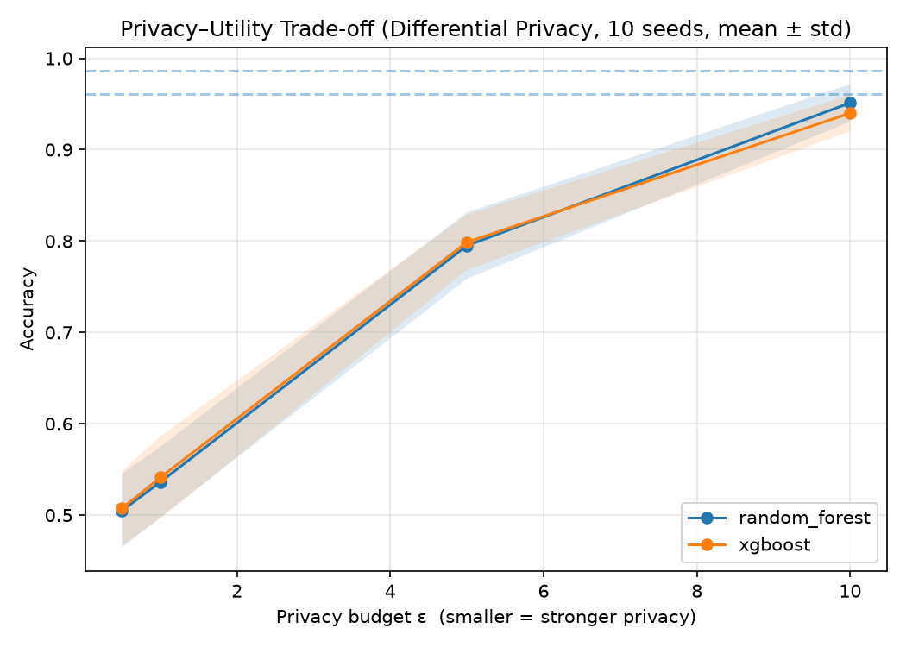
Figure 4.6: Privacy-utility trade-off under Differential Privacy (10-seed mean, shaded band = ± 1 SD), for Random Forest and XGBoost.
The two ensemble models trace an almost identical curve, monotonically declining as ε is reduced and consistent with the formal guarantee described in Section 3.7.1, that a smaller privacy budget permits less variation between outcomes and therefore admits more distortion. Even the least restrictive budget tested, ε = 10, imposes a real and non-trivial cost, a reduction in mean accuracy of 3.50 percentage points for Random Forest and 2.12 points for XGBoost relative to the no-privacy reference. By ε = 5 the cost is substantial: AUC-ROC, the metric least sensitive to the class imbalance noted in Section 3.2, has fallen from a near-perfect 0.999 and 0.996 to 0.873 and 0.876 respectively, a real but partial loss of discriminative power. Between ε = 5 and ε = 1 the curve then collapses: at ε = 1, AUC-ROC for both models is within a few thousandths of 0.55, and at ε = 0.5 it is within a few thousandths of 0.50, the value that denotes a classifier with no discriminative ability whatsoever, no better than assigning risk at random. Because AUC-ROC is computed from the ranking of predicted probabilities and is therefore unaffected by the class imbalance that complicates the accuracy figures, this collapse to chance-level discrimination is the clearest evidence in the study that at these stronger privacy budgets the Gaussian noise introduced by Differential Privacy does not merely degrade the model, it destroys essentially all of the signal the federated ensemble has learned. The practical implication is that this mechanism, applied to the ensemble track as configured here, is usable only in the upper portion of the range examined, and that the boundary between a materially useful model and one indistinguishable from chance lies somewhere between ε = 5 and ε = 1, a considerably stronger privacy budget than might naively be assumed usable from the ε = 1 figures common in the differential-privacy literature reviewed in Section 2.7.

4.4.2 Homomorphic Encryption on the Weight-Based Track
Following the mechanism described in Section 3.7.2, the converged FedAvg Logistic Regression weight vector of Section 4.2.3 was reproduced with every round's aggregation performed under CKKS homomorphic encryption: each client's size-weighted update was encrypted before leaving the client, the server summed the encrypted updates using only a public context that does not hold the secret key, and the encrypted sum was decrypted to obtain the new global weights. Local training was identical, round for round, to the plaintext run of Section 4.2.3, so that any difference between the two is attributable to encryption alone rather than to a different training procedure. The two runs are compared in Figure 4.7.
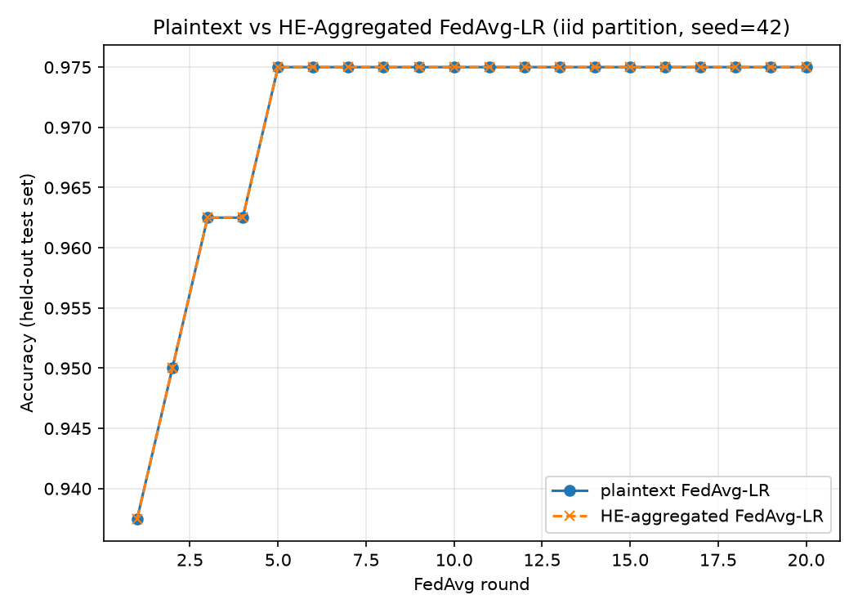
Figure 4.7: Plaintext versus homomorphically encrypted FedAvg Logistic Regression, round by round (IID partition, seed 42). The two curves overlap exactly.
The plaintext and homomorphically encrypted runs produced identical accuracy at every one of the twenty communication rounds, converging to a final accuracy of 0.9750 in both cases, an accuracy difference of 0.000000. This confirms empirically, rather than only by the theoretical argument of Section 3.7.2, that Homomorphic Encryption introduces no noise into the trained model: the encrypted aggregation is, once decrypted, mathematically identical to the plaintext aggregation it replaces. The cost of this protection is instead computational and communicative, and was measured directly. These overhead figures are reported in Table 4.7.
Table 4.7 - Homomorphic Encryption: Computational and Communication Overhead
Metric | Value
Final-round accuracy, plaintext | 0.9750
Final-round accuracy, homomorphically encrypted | 0.9750
Accuracy difference | +0.000000
Encryption time per round (5 clients) | 17.06 ± 0.55 ms
Server aggregation time per round | 3.44 ± 0.34 ms
Decryption time per round | 1.18 ± 0.09 ms
Total wall time, 20 rounds, plaintext | 0.075 s
Total wall time, 20 rounds, homomorphically encrypted | 0.542 s
Slowdown factor | 7.2×
Ciphertext size, one client's update | 1,655,761 bytes
Plaintext size, one client's update | 1,000 bytes
Size blow-up factor | 1655.8×
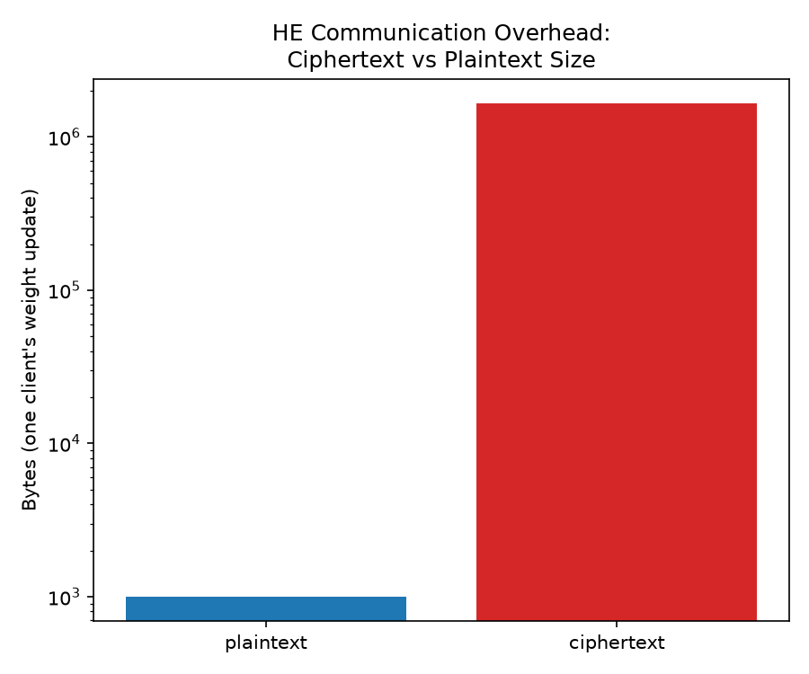
Figure 4.8: Message size per client update, plaintext versus CKKS-encrypted (logarithmic scale).
Encryption is the dominant component of the computational overhead, accounting for roughly 17 milliseconds of the approximately 21.7 millisecond total added per round, more than four times the combined cost of server-side aggregation and decryption; this is consistent with the fact that every one of the five clients must independently encrypt its own weight vector, whereas aggregation and decryption are each performed once per round. Overall, the homomorphically encrypted run took 7.2 times as long as the plaintext run to complete twenty rounds, an overhead that, in absolute terms, remains a fraction of a second in this single-machine simulation, a qualification returned to in Section 4.7. The more operationally significant figure is the size of the message each client must transmit: a 25-dimensional plaintext weight update, 24 coefficients and an intercept, occupies 1,000 bytes as 64-bit floating-point values, whereas its CKKS ciphertext occupies 1,655,761 bytes, an increase by a factor of 1,655.8. In a real multi-institutional deployment, in which model updates are transmitted over a network at every communication round rather than computed once, this size blow-up, not the sub-second computation time measured here, is the cost most likely to determine whether Homomorphic Encryption is practical at scale.

4.4.3 Synthesis: The Privacy-Utility-Efficiency Picture
Sections 4.4.1 and 4.4.2 establish, empirically and within a single coherent framework, the asymmetry that Section 3.7.3 anticipated on theoretical grounds. Differential Privacy, applied to the ensemble track, trades a directly tunable quantity of predictive accuracy for a formally defined privacy guarantee: weakening that guarantee restores accuracy along a smooth, monotonic curve, and strengthening it below approximately ε = 5 drives the model towards, and at ε ≤ 1 essentially to, chance-level discrimination. Homomorphic Encryption, applied to the weight-based track, incurs no accuracy cost whatsoever, verified round by round rather than assumed, but imposes a substantial and directly measured computational and, more significantly, communication overhead. Figure 4.9 places both results side by side.
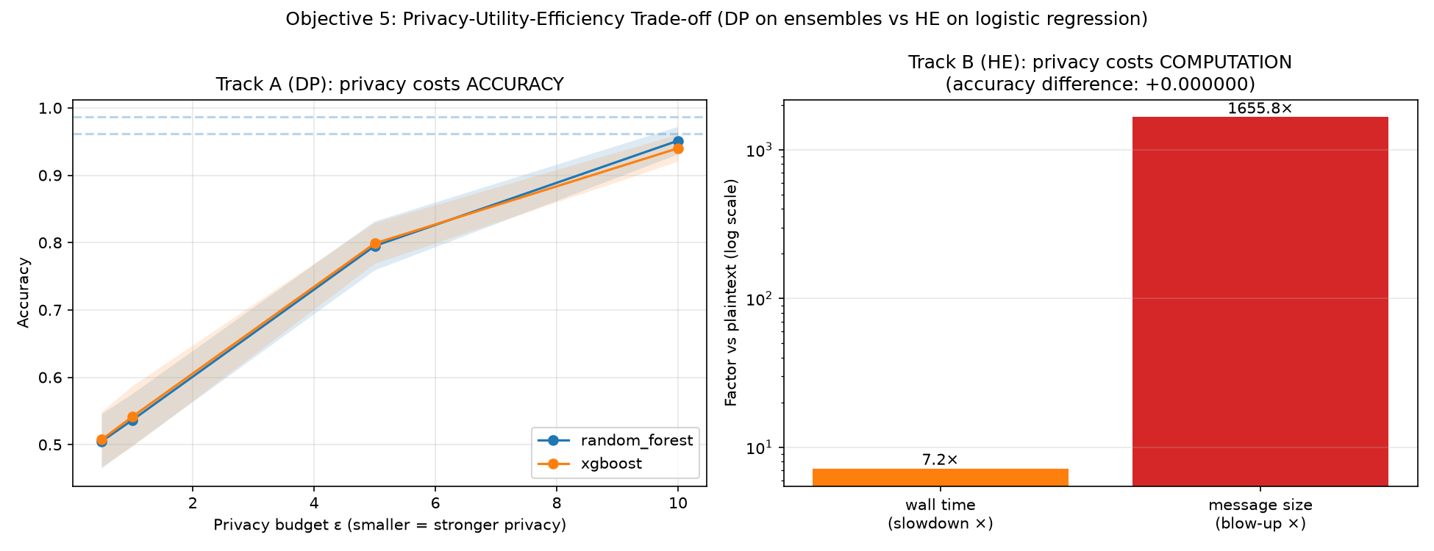
Figure 4.9: The Objective 5 payoff. Left, the Differential Privacy accuracy-versus-ε curve for the ensemble track (Track A). Right, the Homomorphic Encryption overhead for the weight-based track (Track B), plotted on a logarithmic scale against the plaintext baseline, alongside the measured accuracy difference of the encrypted run.
This figure is the principal empirical answer to Objective 5 and the gap identified in Section 2.9. Where the closest prior studies apply Differential Privacy alone (Jahin et al., 2024) or combine both mechanisms without focusing specifically on early CKD detection using interpretable ensemble models (Health-FedNet), this study places both mechanisms within the same federated, explainable, ensemble-based CKD framework and quantifies, on identical data and under identical partitioning, what each actually costs: Differential Privacy costs accuracy, tunably and predictably; Homomorphic Encryption costs computation and, more sharply, communication bandwidth, while leaving accuracy untouched. Neither mechanism is unconditionally preferable; the two-track design of Section 3.5, which this result vindicates, exists precisely because the choice between them is a choice between the kind of cost a federated CKD deployment is better able to absorb, a question addressed further in the integrated evaluation of Section 4.5 and the discussion of Section 4.6.

4.5 INTEGRATED EVALUATION AGAINST THE FIVE OBJECTIVES
Sections 4.1 to 4.4 have presented the results of the framework one dimension at a time, predictive performance, federated robustness, interpretability, and privacy. Objective 4 asks that the framework be evaluated not only along each of these dimensions separately but as a whole, since a system that performs well on one dimension while failing another would not satisfy the aim set out in Section 1.3. Table 4.8 draws the preceding results together against each of the five objectives in turn, and the discussion that follows addresses the framework's coherence as an integrated system rather than as five independent experiments.
Table 4.8 - Summary of Evidence Against the Five Research Objectives
Objective | Evidence | Section
1. Federated learning architecture | Five-client server/client architecture (§3.4) trained successfully under IID, non-IID, and non-IID-equal partitioning; federation cost of 0.75-2.62 points (ensemble track) and 0.12 points (weight-based track) relative to the centralised baseline. | 4.2
2. High-performance ensemble models | Random Forest and XGBoost trained centrally to 0.9906 and 0.9844 cross-validated accuracy respectively, with test-set recall of 1.0000 and 0.9800. | 4.1
3. Explainable AI integration | SHAP (global) and LIME (local) applied to the converged federated model; top-ranked features (haemoglobin, specific gravity, serum creatinine, albumin) corroborate independent published findings; LIME stability (Jaccard = 1.000) and fidelity (R² = 0.299) quantified directly. | 4.3
4. Evaluate performance and trustworthiness | Three-dimensional evaluation conducted throughout, predictive metrics (§3.8.1), interpretability metrics (§3.8.2), and privacy/efficiency metrics (§3.8.3), on a shared held-out test set and a shared federated architecture, rather than as isolated analyses. | 4.1-4.4
5. Privacy-utility trade-off analysis | Differential Privacy on the ensemble track: accuracy cost rising from 3.5 points at ε = 10 to chance-level discrimination at ε ≤ 1. Homomorphic Encryption on the weight-based track: zero accuracy cost, 7.2x time overhead, 1655.8x message-size overhead. | 4.4
What this integration demonstrates, beyond the individual results themselves, is that the five objectives are not independent design requirements bolted onto a common dataset but form a single dependency chain. The federated architecture of Objective 1 supplies the client partitions on which the ensemble and weight-based models of Objective 2 are trained; the converged global model these produce is what the explainability layer of Objective 3 interprets, locally at each node, without any raw data being centralised for that purpose; the evaluation of Objective 4 is conducted on the same held-out test set throughout, so that predictive, interpretability, and privacy results are directly comparable rather than drawn from incompatible experimental conditions; and the privacy mechanisms of Objective 5 are applied to the specific model tracks that Objectives 1 and 2 established, tree ensembles and a weight-based model respectively, precisely because those tracks differ structurally in the manner Section 3.5 sets out. No objective could be removed without altering what the remaining four are able to demonstrate.

4.6 DISCUSSION: COMPARISON WITH RELATED WORK AND THE RESEARCH GAP
Section 2.8 grouped prior work on CKD prediction into four categories: conventional machine-learning studies, explainable-AI studies, federated-learning studies, and the small number of studies combining privacy preservation with interpretability. The results of this chapter are now read against each in turn, before returning to the specific gap Section 2.9 identified.
Against the conventional machine-learning studies, the centralised baseline of Section 4.1 sits squarely within the range this literature reports: Poonia et al. (2022) obtained 98.75 per cent accuracy with logistic regression, matched almost exactly by the 0.9875 obtained here; Qin et al. (2020) and Khalid et al. (2023) reported 99.83 and 100 per cent respectively. Section 4.1 already cautioned that this consistency reflects the separability of a small, widely reused benchmark dataset rather than any particular advance in modelling, and the present study does not claim otherwise; its contribution lies not in exceeding this ceiling but in what is built on top of a model that reaches it, decentralisation, explanation, and formal privacy protection, none of which the conventional studies attempt.
Against the explainable-AI studies, the SHAP results of Section 4.3.1 do more than replicate prior findings; they corroborate them directly. Ahmed et al. (2024) identified haemoglobin, albumin, serum creatinine, and estimated glomerular filtration rate as the SHAP features most consistently reported across the CKD literature they reviewed, a set matching four of the five top-ranked features in Table 4.4; Haque et al. (2025), using the same UCI dataset, identified specific gravity and haemoglobin as the two most important features, matching the first two ranks in Table 4.4 exactly. Ghosh and Khandoker (2024) reported an XGBoost AUC of 0.9689 and an accuracy of 93.29 per cent on centralised data; the federated XGBoost model of Section 4.2.1 matches or exceeds this, with a mean AUC of 0.996 to 0.998 and a mean accuracy of 96.13 to 97.63 per cent depending on partitioning scheme, despite being trained under federation rather than on pooled data. None of the explainable-AI studies reviewed in Section 2.6.3, however, was conducted in a federated setting; the present study reproduces their interpretability findings while adding the decentralisation that Section 2.4.2 identifies as a precondition for multi-institutional deployment in the first place.
Against the federated-learning studies, Salmeron et al. (2023) provides the closest precedent for the federated architecture itself, federating the same UCI CKD dataset across five simulated hospitals under even and uneven distributions. That study, by the authors' own statement, incorporates no explainability layer and no privacy-preserving mechanism. The present study extends this precedent directly: the same dataset, a comparable number of simulated hospitals, and both IID and non-IID partitioning, now combined with the SHAP and LIME analysis of Section 4.3 and the Differential Privacy and Homomorphic Encryption analysis of Section 4.4, neither of which Salmeron et al. address. Hegde et al. (2025) applied Homomorphic Encryption to a federated CKD model after demonstrating the vulnerability of an unprotected federated setup to inversion and gradient-leakage attacks, but did not compare Homomorphic Encryption against Differential Privacy, nor integrate explainability; the HE overhead findings of Section 4.4.2 are broadly consistent with the computational cost that study identifies as the price of encryption-based protection, while this study additionally quantifies that cost in the specific terms, time and message size, reported in Table 4.7.
Against the combined privacy-preserving and explainable studies, the closest prior work, Jahin et al. (2024) integrates federation, Differential Privacy, and SHAP-based explainability, but relies on Differential Privacy alone, applied through DP-SGD to a HistGradientBoosting model, and does not examine Homomorphic Encryption or the two-track design this necessitates. Health-FedNet combines Differential Privacy, Homomorphic Encryption, and SHAP within one federated framework, the most complete combination in the literature reviewed in Section 2.8, but is evaluated on the general chronic-disease population of MIMIC-III rather than on CKD specifically, and is not built around the ensemble models or the CKD biomarker features that Section 4.3 shows to align so closely with clinical knowledge. The present study is, on the evidence assembled in this chapter, the first to report a direct, quantified, cross-track comparison of Differential Privacy and Homomorphic Encryption within a federated framework built specifically for interpretable, ensemble-based early CKD detection, closing the gap Section 2.9 identifies: no existing study combining a federated architecture, interpretable ensemble models, dual SHAP and LIME explanation, and an empirical Differential-Privacy-versus-Homomorphic-Encryption analysis within one framework for CKD detection. The results of Sections 4.1 to 4.4 demonstrate that combination in practice rather than only in design.

4.7 LIMITATIONS OF THE FINDINGS
Section 1.6 disclosed, in advance of any result, three limitations bearing on how this study should be interpreted. Each is now revisited in light of the specific evidence produced in this chapter, alongside two further limitations that emerged from the results themselves.
The dataset is small and highly separable. Every centralised, federated, and even privacy-degraded result in this chapter reflects a four-hundred-record dataset on which several independent published studies, surveyed in Section 2.8, report accuracies clustered near or at the same 98 to 100 per cent ceiling reached in Section 4.1. This is precisely why the more informative results in this chapter are relative ones, the federation cost of Section 4.2.2 and the privacy cost of Section 4.4.1, rather than the absolute accuracy figures themselves, and it bears specifically on the finding, in Section 4.2.1, that the federated ensemble models were robust to non-IID partitioning: this robustness may reflect the ease of this particular classification task as much as any general insensitivity of Federated Averaging to statistical heterogeneity, and should not be extrapolated to a larger or noisier clinical dataset without further testing.
The simulated hospital nodes are partitions of a single public dataset rather than genuinely independent institutions. The IID and non-IID schemes of Section 3.4.2 introduce controlled statistical heterogeneity, differing class proportions and, in the fully non-IID case, differing client sizes, but they cannot reproduce the additional sources of heterogeneity that distinguish real hospitals: differing laboratory equipment and reference ranges, differing clinical recording practices, and demographically distinct patient populations. The federation cost and non-IID robustness findings of Section 4.2 should accordingly be read as a lower bound on the challenge a genuine multi-hospital deployment would present, not as an estimate of it.
The computational and communication overhead of Homomorphic Encryption was measured within a single-machine simulation. The time overheads reported in Table 4.7, an encryption cost of some seventeen milliseconds per round and a sevenfold slowdown overall, are specific to the hardware on which the experiments were run and to a federation of five clients over twenty rounds; they do not include the network transmission time that the 1655.8-fold increase in message size, reported in the same table, would actually incur over a real inter-hospital network connection. That size increase is measured directly and does not depend on the simulation, and Section 4.4.2 accordingly treated it, rather than the wall-clock timings, as the more operationally significant of the two overhead figures, but neither figure should be taken as a prediction of performance in a live deployment.
The interpretability metrics of Section 4.3.3 were computed for a single model, XGBoost, and five patients. The perfect stability and the moderate fidelity reported in Table 4.5 are consistent findings across those five cases, but a larger and more diverse patient sample, and the equivalent analysis applied to Random Forest, would be required before the specific numerical values, an R² of 0.299 in particular, could be generalised beyond the cases examined here. The finding that fidelity is the more binding constraint on LIME's explanations than stability is, on the present evidence, better treated as a directional conclusion than a precisely estimated quantity.
Finally, the Differential Privacy results of Section 4.4.1 reflect one specific mechanism, Gaussian noise applied to each client's output probabilities with a sensitivity of 1.0, among several ways Differential Privacy could be incorporated into a federated ensemble. Jahin et al. (2024), for comparison, applies Differential Privacy at the gradient level through DP-SGD, a mechanism operating at a different point in the training pipeline and likely to trace a different privacy-utility curve at the same nominal values of ε. The specific epsilon values at which the curve of Figure 4.6 collapses to chance-level discrimination are therefore a property of the output-perturbation mechanism implemented here, a documented and conservative methodological choice, and should not be read as a universal property of differential privacy applied to federated ensemble models in general.

CHAPTER FIVE

CONCLUSION

5.0 INTRODUCTION
This chapter concludes the thesis. Section 5.1 summarises the study as a whole; Section 5.2 restates its findings against each of the five research objectives set out in Section 1.4; Section 5.3 sets out the study's contributions to knowledge; Section 5.4 offers recommendations for practitioners considering a similar deployment; Section 5.5 identifies directions for future research, building directly on the limitations established in Section 4.7; and Section 5.6 closes the thesis.

5.1 SUMMARY OF THE STUDY
This study set out, as stated in Section 1.3, to develop, implement, and evaluate a decentralised, privacy-preserving, and interpretable machine-learning framework for the early detection of Chronic Kidney Disease from multi-institutional Electronic Health Records. The framework, described in full in Chapter Three, partitions the UCI CKD dataset across five simulated hospital nodes under both IID and non-IID distributions, and adopts a two-track design distinguished by how each track's model can be aggregated and protected: a primary track, Random Forest and XGBoost, aggregated by size-weighted averaging of client outputs and protected by Differential Privacy, since tree ensembles cannot be averaged as parameter vectors; and a secondary track, Logistic Regression, aggregated by genuine parameter-level Federated Averaging and protected by Homomorphic Encryption, since only a weight-based model can be encrypted and aggregated while encrypted. SHAP and LIME were applied to the converged federated model to render its predictions interpretable, and the entire framework was evaluated along three dimensions, predictive performance, interpretability, and privacy, on a shared held-out test set and under a consistent, ten-seed reproducibility protocol. Chapter Four reported the results of this evaluation in detail. The centralised and federated ensemble models achieved near-ceiling predictive performance, the SHAP feature ranking corroborated independently published clinical findings, LIME's explanations proved perfectly stable but only moderately faithful to the underlying model, and, at the centre of the study, Differential Privacy and Homomorphic Encryption were shown empirically to impose two qualitatively different costs, a tunable loss of accuracy in the first case and a substantial computational and communication overhead at no accuracy cost in the second.

5.2 SUMMARY OF FINDINGS AGAINST THE RESEARCH OBJECTIVES
Table 5.1 restates, in condensed form, how each of the five objectives set out in Section 1.4 was addressed and what the evidence of Chapter Four established.
Table 5.1 - Objectives and Principal Findings
Objective | Principal Finding
1. Federated learning architecture | A five-client server/client architecture was designed and implemented, trained successfully under IID and non-IID partitioning, at a modest federation cost of 0.75 to 2.62 percentage points for the ensemble track and 0.12 points for the weight-based track.
2. High-performance predictive models | Random Forest and XGBoost were developed and optimised, reaching cross-validated accuracies of 0.9906 and 0.9844 and test-set recall of 1.0000 and 0.9800 respectively.
3. Explainable AI integration | SHAP and LIME were integrated and applied to the federated global model without centralising data; the resulting explanations were shown to be clinically coherent, consistent with independently published findings, and, for LIME, quantifiably stable though only moderately faithful (R² = 0.299).
4. Evaluation of performance and trustworthiness | A three-dimensional evaluation, predictive, interpretability, and privacy, was conducted on a consistent held-out test set and federated architecture throughout, rather than as separate, incomparable analyses.
5. Privacy-utility trade-off analysis | Differential Privacy and Homomorphic Encryption were compared directly within one framework: Differential Privacy traded accuracy for privacy, collapsing to chance-level discrimination between ε = 5 and ε = 1; Homomorphic Encryption preserved accuracy exactly, at a 7.2x time overhead and a 1655.8x message-size overhead.

5.3 CONTRIBUTIONS TO KNOWLEDGE
Beyond satisfying its five objectives, the study makes four specific contributions to the literature reviewed in Chapter Two.
1. A validated two-track architecture for privacy-heterogeneous federated ensembles. The finding, established in Section 3.5.1 and confirmed empirically throughout Chapter Four, that Homomorphic Encryption cannot be applied to tree ensembles because they are structural rather than parametric, motivates a general design pattern, matching the privacy mechanism to the aggregation mechanism each model track actually supports, rather than assuming a single privacy technology must be applied uniformly across a federated system.
2. The first direct, quantified, cross-track comparison of Differential Privacy and Homomorphic Encryption for federated CKD detection. Where the closest prior studies, Jahin et al. (2024) and Health-FedNet, apply Differential Privacy alone or combine both mechanisms without a CKD-specific, ensemble-based focus, this study reports both mechanisms' costs, in comparable, measured units, accuracy points for the one and time and bytes for the other, within a single reproducible framework.
3. A more precise characterisation of the Differential Privacy usable range for this class of model. Rather than assuming, as much of the literature reviewed in Section 2.7 implicitly does, that a privacy budget of ε = 1 represents a reasonable operating point, Section 4.4.1 shows, using AUC-ROC to control for class imbalance, that the federated ensemble models examined here collapse to chance-level discrimination at or before that value, and that even ε = 10 imposes a non-trivial accuracy cost.
4. Quantified, rather than assumed, interpretability metrics. Section 4.3.3 measured LIME's fidelity and stability directly rather than treating interpretability as satisfied once an explanation is produced, revealing that stability and fidelity can diverge sharply, and that a stable explanation is not automatically a faithful one.

5.4 RECOMMENDATIONS
On the basis of the results in Chapter Four, the following recommendations are offered to practitioners considering a similar federated CKD detection system.
1. Where Differential Privacy is applied to a federated tree ensemble by output perturbation, as in this study, a privacy budget no smaller than ε = 10 should be treated as a starting point, not a conservative floor: Section 4.4.1 found accuracy already measurably reduced at that value, and discrimination lost entirely by ε = 1.
2. Where Homomorphic Encryption is used, network bandwidth, not computation time, should be the primary planning constraint: Section 4.4.2 found a 1655.8-fold increase in the size of each transmitted model update, against only a 7.2-fold increase in processing time.
3. In a federated system combining structurally different model families, the two-track pattern of Section 3.5, matching each privacy mechanism to the aggregation method its model track actually supports, is recommended over attempting to force a single privacy technology across every model in the system.
4. Recall should be monitored explicitly, and not subordinated to overall accuracy, in any CKD screening deployment, given the clinical asymmetry between a missed diagnosis and a false alarm discussed in Section 3.8.1.
5. LIME explanations should be presented to clinicians as a reliable guide to which features drove a prediction and in which direction, rather than as a precise quantitative account of the model's reasoning, and should where possible be paired with a global, exact method such as TreeSHAP, as was done in this study, rather than relied upon alone.

5.5 DIRECTIONS FOR FUTURE WORK
The limitations set out in Section 4.7 point directly to six directions for future research.
1. Validation on a larger and more clinically representative Electronic Health Record dataset, to establish whether the near-ceiling predictive performance and the non-IID robustness observed in Section 4.2.1 persist beyond the four-hundred-record UCI benchmark used here.
2. Deployment across genuinely separate institutional systems rather than simulated single-machine partitions, to capture the equipment, recording, and demographic heterogeneity that Section 4.7 notes the simulated non-IID schemes cannot fully reproduce, and to measure the Homomorphic Encryption communication overhead of Section 4.4.2 under real network conditions.
3. A comparison of the output-perturbation Differential Privacy mechanism used here against gradient-level mechanisms such as the DP-SGD approach of Jahin et al. (2024), to establish whether the ε = 5 to ε = 1 collapse threshold identified in Section 4.4.1 is specific to the mechanism examined or a broader property of applying Differential Privacy to federated ensembles.
4. Extension of the fidelity and stability measurements of Section 4.3.3 to Random Forest and to a larger, more diverse sample of patients, to establish how generally the specific values reported here, and the divergence between stability and fidelity in particular, hold.
5. Investigation of hybrid or emerging privacy schemes capable of narrowing the gap the two-track design of Section 3.5 was built around, including encryption schemes capable of operating directly on tree-structured models, which would remove the structural constraint that currently confines Homomorphic Encryption to the weight-based track.
6. Extension of the quantitative fidelity and stability analysis of Section 4.3.3 to SHAP as well as LIME, so that both explanation methods used in this study are evaluated by the same standard.

5.6 CONCLUDING REMARKS
This study set out to determine whether a Chronic Kidney Disease detection system could be simultaneously accurate, interpretable, and privacy-preserving, without requiring patient data to be centralised. The evidence presented in Chapter Four indicates that it can, and quantifies, more precisely than the prior literature reviewed in Chapter Two, what each additional guarantee costs: decentralisation costs a few percentage points of accuracy; formal Differential Privacy costs accuracy on a curve that steepens sharply below ε = 5; and Homomorphic Encryption costs computation and, more sharply, communication bandwidth, while leaving accuracy untouched entirely. None of these costs is negligible, and none of the findings in this thesis should be read as suggesting otherwise; but each is now measured, on a shared federated architecture and a shared dataset, rather than assumed, and it is this measurement, drawing together federated learning, explainable AI, and a direct empirical comparison of two distinct privacy-enhancing technologies within a single framework for early CKD detection, that constitutes the study's answer to the gap identified in Section 2.9.

REFERENCES
Alenezi, A. et al. (2024) 'Predictive modeling of Kuwaiti chronic kidney diseases (KCKD): leveraging electronic health records for clinical decision-making', International Journal of Advanced Computer Science and Applications, 15(2).
Almogadwy, B. and Alqarafi, A. (2025) 'Fused federated learning framework for secure and decentralized patient monitoring in healthcare 5.0 using IoMT', Scientific Reports, 15(1), article 24263. doi:10.1038/s41598-025-06574-w.
Antunes, R.S., André da Costa, C., Küderle, A., Yari, I.A. and Eskofier, B. (2022) 'Federated learning for healthcare: systematic review and architecture proposal', ACM Transactions on Intelligent Systems and Technology, 13(4), pp. 1–23. doi:10.1145/3501813.
Benaissa, A., Retiat, B., Cebere, B. and Belfedhal, A.E. (2021) 'TenSEAL: a library for encrypted tensor operations using homomorphic encryption', arXiv preprint arXiv:2104.03152.
Beutel, D.J. et al. (2020) 'Flower: a friendly federated learning research framework', arXiv preprint arXiv:2007.14390.
Breiman, L. (2001) 'Random forests', Machine Learning, 45(1), pp. 5–32. doi:10.1023/A:1010933404324.
Chen, T. and Guestrin, C. (2016) 'XGBoost: a scalable tree boosting system', Proceedings of the 22nd ACM SIGKDD International Conference on Knowledge Discovery and Data Mining, pp. 785–794. doi:10.1145/2939672.2939785.
Chen, T.K., Knicely, D.H. and Grams, M.E. (2019) 'Chronic kidney disease diagnosis and management: a review', JAMA, 322(13), pp. 1294–1304. doi:10.1001/jama.2019.14745.
Cheon, J.H., Kim, A., Kim, M. and Song, Y. (2017) 'Homomorphic encryption for arithmetic of approximate numbers', Advances in Cryptology – ASIACRYPT 2017, pp. 409–437. doi:10.1007/978-3-319-70694-8_15.
Chouit, E.M., Rachdi, M., Bellafkih, M. and Raouyane, B. (2026) 'Interpretable machine learning for chronic kidney disease prediction: insights from SHAP and LIME analyses', PLOS One. doi:10.1371/journal.pone.0343205.
Cleveland Clinic (2025) Kidney: anatomy, function and health. Available at: [add URL] (Accessed: [add date]).
Cleveland Clinic (2026) Chronic kidney disease: management and treatment. Available at: [add URL] (Accessed: [add date]).
Deepika, C.D.N. and Anusha, S. (2024) 'Federated learning approach for chronic kidney disease prediction', Proceedings of the International Conference on Computing and Communication Technologies.
Elshewey, A.M. et al. (2025) 'Improved CKD classification based on explainable artificial intelligence with extra trees and BBFS', Scientific Reports. doi:10.1038/s41598-025-02355-7.
Emon, M.U., Imran, A.M., Islam, R., Keya, M.S., Zannat, R. and Ohidujjaman (2021) 'Performance analysis of machine learning approaches in automatic classification of chronic kidney disease', Proceedings of the 5th International Conference on Intelligent Computing and Control Systems (ICICCS), pp. 713–719. doi:10.1109/ICICCS51141.2021.9432386.
GBD Chronic Kidney Disease Collaborators (2025) 'Global, regional, and national burden of chronic kidney disease in adults, 1990–2023, and its attributable risk factors: a systematic analysis for the Global Burden of Disease Study 2023', The Lancet. doi:10.1016/S0140-6736(25)01853-7.
Ghosh, S.K. and Khandoker, A.H. (2024) 'Investigation on explainable machine learning models to predict chronic kidney diseases', Scientific Reports, 14, article 3687. doi:10.1038/s41598-024-54375-4.
Gogoi, P. and Arul Valan, J. (2024) 'Machine learning approaches for predicting and diagnosing chronic kidney disease: current trends, challenges, solutions, and future directions', International Urology and Nephrology. doi:10.1007/s11255-024-04281-5.
Gogoi, P. and Valan, J.A. (2025) 'Interpretable machine learning for chronic kidney disease prediction: a SHAP and genetic algorithm-based approach', Biomedical Materials & Devices, 3, pp. 1384–1402. doi:10.1007/s44174-024-00262-5.
Haque, M.E., Islam, S.M.J., Maliha, J., Sumon, M.S.H., Sharmin, R. and Rokoni, S. (2025) 'Improving chronic kidney disease detection efficiency: fine-tuned CatBoost and nature-inspired algorithms with explainable AI', arXiv preprint arXiv:2504.04262.
Hannan, M. et al. (2021) 'Risk factors for CKD progression: overview of findings from the CRIC study', Current Opinion in Nephrology and Hypertension, 30(1), pp. 105–114.
Hegde, M.G., Ruthvika, B., Jain, R.B., Shenoy, P.D., Venugopal, K.R. and Canchi, A. (2025) 'A privacy-preserving federated learning method with homomorphic encryption for chronic kidney disease stage prediction', Engineering, Technology & Applied Science Research, 15(4), pp. 26019–26026. doi:10.48084/etasr.11928.
Hossain, K.M.Z. et al. (2025) 'Implementing explainable AI for early detection of chronic kidney disease: strategic insights for health information systems management', Journal of Computer Science and Technology Studies, 7(5). doi:10.32996/jcsts.2025.7.5.19.
IBM (2023) What is machine learning? Available at: [add URL] (Accessed: [add date]).
Islam, M.A., Majumder, M.Z.H. and Hussein, M.A. (2024) 'ML-CKDP: machine learning-based chronic kidney disease prediction with smart web application', Journal of Pathology Informatics, 14, article 100189. doi:10.1016/j.jpi.2023.100189.
Jager, K.J. et al. (2019) 'A single number for advocacy and communication — worldwide more than 850 million individuals have kidney diseases', Kidney International, 96(5), pp. 1048–1050. doi:10.1016/j.kint.2019.07.012.
Jahin, M.A. et al. (2024) 'Privacy-preserving and explainable multi-hospital CKD prediction via federated learning with blockchain logging and differential privacy'. (Preprint.)
Jawad, K., Verma, A. and Amsaad, F. (2024) 'AI-driven predictive analytics approach for early prognosis of chronic kidney disease using ensemble learning and explainable AI', arXiv preprint arXiv:2406.06728. doi:10.48550/arXiv.2406.06728.
Khalid, F., Alsadoun, L., Khilji, F., Mushtaq, M., Eze-odurukwe, A., Mushtaq, M.M., Ali, H., Farman, R.O., Ali, S.M., Fatima, R. and Bokhari, S.F.H. (2024) 'Predicting the progression of chronic kidney disease: a systematic review of artificial intelligence and machine learning approaches', Cureus, 16(5), e60145. doi:10.7759/cureus.60145.
Khalid, H., Khan, A., Zahid Khan, M., Mehmood, G. and Shuaib Qureshi, M. (2023) 'Machine learning hybrid model for the prediction of chronic kidney disease', Computational Intelligence and Neuroscience, 2023, article 9266889. doi:10.1155/2023/9266889.
Kidney Disease: Improving Global Outcomes (KDIGO) CKD Work Group (2024) 'KDIGO 2024 clinical practice guideline for the evaluation and management of chronic kidney disease', Kidney International, 105(4S), pp. S117–S314. doi:10.1016/j.kint.2023.10.018.
Krishnamurthy, S. et al. (2020) 'Machine learning prediction models for chronic kidney disease using National Health Insurance claim data in Taiwan', medRxiv. doi:10.1101/2020.06.25.20139147.
Levey, A.S. et al. (2005) 'Definition and classification of chronic kidney disease: a position statement from Kidney Disease: Improving Global Outcomes (KDIGO)', Kidney International, 67(6), pp. 2089–2100. doi:10.1111/j.1523-1755.2005.00365.x.
Lundberg, S.M. and Lee, S.-I. (2017) 'A unified approach to interpreting model predictions', Advances in Neural Information Processing Systems (NeurIPS), 30, pp. 4765–4774.
McMahan, B., Moore, E., Ramage, D., Hampson, S. and Agüera y Arcas, B. (2017) 'Communication-efficient learning of deep networks from decentralized data', Proceedings of the 20th International Conference on Artificial Intelligence and Statistics (AISTATS), PMLR 54, pp. 1273–1282.
Nguyen, D.C., Ding, M., Pathirana, P.N., Seneviratne, A., Li, J. and Poor, H.V. (2021) 'Federated learning for internet of things: a comprehensive survey', IEEE Communications Surveys & Tutorials, 23(3), pp. 1622–1658. doi:10.1109/COMST.2021.3075439.
Nguycharoen, N. (2024) 'Explainable machine learning system for predicting chronic kidney disease in high-risk cardiovascular patients', arXiv preprint arXiv:2404.11148. doi:10.48550/arXiv.2404.11148.
Paillier, P. (1999) 'Public-key cryptosystems based on composite degree residuosity classes', Advances in Cryptology – EUROCRYPT 1999, pp. 223–238. doi:10.1007/3-540-48910-X_16.
Pal, S. (2023) 'Chronic kidney disease prediction using machine learning techniques', Biomedical Materials & Devices, 1, pp. 534–540.
Pedregosa, F. et al. (2011) 'Scikit-learn: machine learning in Python', Journal of Machine Learning Research, 12, pp. 2825–2830.
Poonia, R.C., Gupta, M.K., Abunadi, I., Albraikan, A.A., Al-Wesabi, F.N. and Hamza, M.A. (2022) 'Intelligent diagnostic prediction and classification models for detection of kidney disease', Healthcare, 10(2), article 371. doi:10.3390/healthcare10020371.
Pradana, A. (2023) 'Data-driven early diagnosis of chronic kidney disease: development and evaluation of an explainable AI model', IEEE Access. doi:10.1109/ACCESS.2023.3264270.
Qin, J., Chen, L., Liu, Y., Liu, C., Feng, C. and Chen, B. (2020) 'A machine learning methodology for diagnosing chronic kidney disease', IEEE Access, 8, pp. 20991–21002. doi:10.1109/ACCESS.2019.2963053.
Raihan, M. et al. (2023) 'Detection of the chronic kidney disease using XGBoost classifier and explaining the influence of the attributes on the model using SHAP', Scientific Reports, 13(1), article 5643.
Rauniyar, A. et al. (2024) 'Federated learning for medical applications: a taxonomy, current trends, challenges, and future research directions', IEEE Internet of Things Journal, 11(5), pp. 7374–7398. doi:10.1109/JIOT.2023.3329061.
Raza, A., Arif, H., Sajid Ali, A.K. and Shah, B.K. (2025) 'Privacy-preserving machine learning models to derive risk factors of kidney disease in EHRs'. IEEE. Available at: https://ieeexplore.ieee.org/document/11200980.
Rezk, N.G. et al. (2025) 'Explainable AI for chronic kidney disease prediction in medical IoT: integrating GANs and few-shot learning', Bioengineering, 12(4), article 356. doi:10.3390/bioengineering12040356.
Ribeiro, M.T., Singh, S. and Guestrin, C. (2016) '"Why should I trust you?": explaining the predictions of any classifier', Proceedings of the 22nd ACM SIGKDD International Conference on Knowledge Discovery and Data Mining, pp. 1135–1144. doi:10.1145/2939672.2939778.
Ridwan, L. (2024) Federated learning for privacy-preserving early diagnosis of chronic diseases across distributed healthcare systems. (Preprint.)
Rubini, L., Soundarapandian, P. and Eswaran, P. (2015) Chronic kidney disease [Dataset]. UCI Machine Learning Repository. doi:10.24432/C5G020.
Saif, D., Sarhan, A.M. and Elshennawy, N.M. (2024) 'Machine learning techniques in chronic kidney diseases: a comparative study of classification model performance', Cureus. [verify volume/issue on the Cureus page]
Salmeron, J.L., Arévalo, I. and Ruiz-Celma, A. (2023) 'Benchmarking federated strategies in peer-to-peer federated learning for biomedical data', Heliyon, 9, e16925. doi:10.1016/j.heliyon.2023.e16925 (preprint arXiv:2402.10135).
Shahid, M.I., Badar, H.M.S., Asghar, M.N. and Abdullah, A. (2026) 'Health-FedNet: secure federated learning for chronic disease prediction on MIMIC-III with differential privacy and homomorphic encryption', Scientific Reports, 16, article 7968. doi:10.1038/s41598-026-36034-y.
Sharma, G. et al. (2026) 'Privacy-preserving federated learning via differential privacy and homomorphic encryption for cardiovascular disease risk modeling', arXiv preprint arXiv:2604.27598.
Shivhare, A., Kumari, A.C. and Srinivas, K. (2025) 'Predictive modeling for chronic kidney disease: a comparative analysis of machine learning techniques with explainable AI for clinical transparency', International Journal of Education and Management Engineering, 15(3).
Talib, R., Hameed, M., Ali, I., Khan, A., Iftikhar, H., Azam, M., Khurshid, F., Ali, M. and Hafeez, S. (2024) 'AI-enabled intelligent nephrology: comparative analysis of artificial intelligence models for robust early prediction and clinical evaluation of chronic kidney disease', Pakistan Journal of Medical and Care Research. doi:10.5281/zenodo.19874375.
UK Kidney Association (2024) CKD stages. Available at: [add URL] (Accessed: [add date]).
Wu, Y. et al. (2025) 'Towards interpretable renal health decline forecasting via multi-LMM collaborative reasoning framework', IEEE IRI. doi:10.1109/IRI66576.2025.00059.
Yadav, S.A., Malik, V., Sharma, S., Singh, S.V., Saudagar, A.K.J., Mohamed, H.G. and Hussen, S. (2026) 'Federated learning with IoT-based remote patient monitoring for real-time chronic disease prediction', Journal of King Saud University – Computer and Information Sciences. doi:10.1007/s44443-026-00632-7.
Zhang, J., Kowsari, K., Boukhechba, M., Harrison, J.H. and Lobo, J.M. et al. (2020) 'Sparse longitudinal representations of electronic health record data for the early detection of chronic kidney disease in diabetic patients', arXiv preprint arXiv:2011.04802 (IEEE BIBM 2020).

